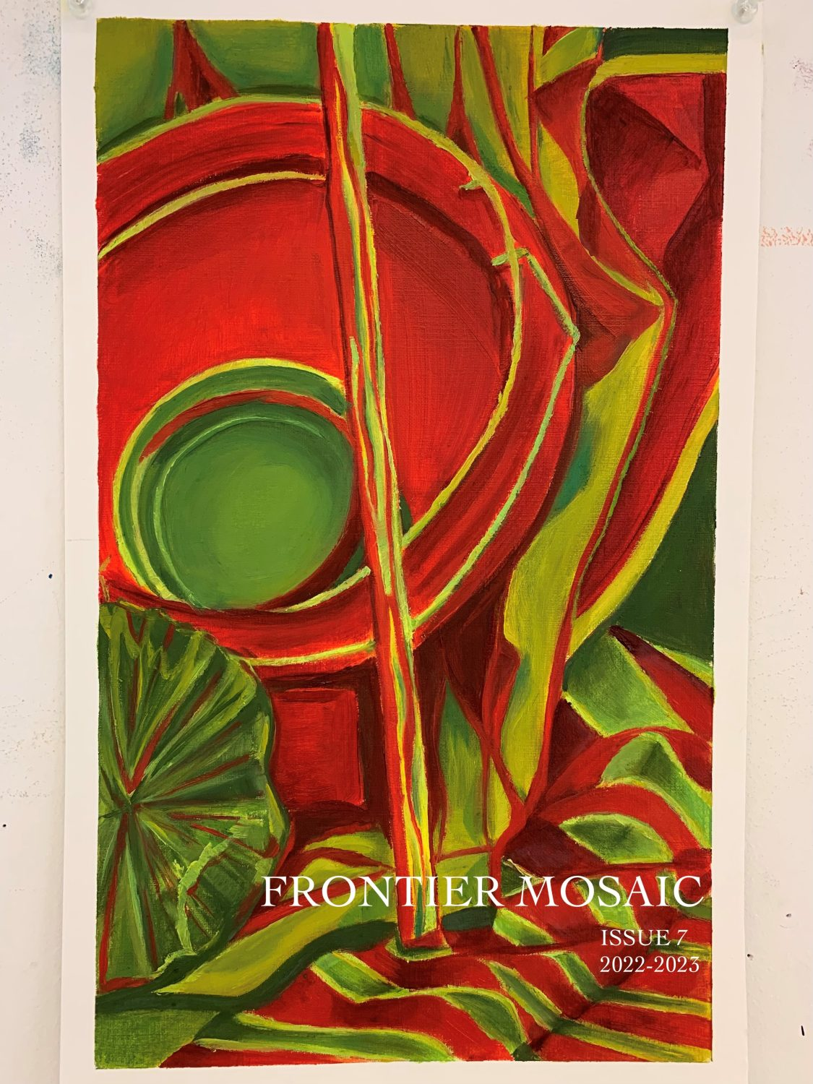

Frontier Mosaic

Frontier Mosaic

Aaron Ellis; Amaya Banks; Corben Horten; G.E. Bradford; Gabriel Parker; Jennifer Nabicht; Kaia Mortensen; KD Leigh; and Sydney Sheneman
Oklahoma State University Libraries
Stillwater, OK

Frontier Mosaic by individual authors is licensed under a Creative Commons Attribution 4.0 International License, except where otherwise noted.
Each author retains ownership over their work. While the overall book is licensed CC-BY, we ask that if individual pieces are used in other ways they are carried forward in their entirety, used only for non-commercial purposes, and include attribution which points back to the individual author as well as this publication. Contact kathy.essmiller@okstate.edu if you have questions.

Contents
- About Frontier Mosaic
- MASTHEAD
- Table of Contents
- Coup de Foudre
Justice Rebmann
- Nothing New Under the Sun
Gabriel Parker
- Looking Up Dreaming
G.E. Bradford
- 444
Amaya Banks
- Still Life With Peach
Justice Rebmann
- Pecking Crow
Jennifer Nabicht
- Striking Matches
Justice Rebmann
- How to Hold a Paintbrush
Gabriel Parker
- Baby, I AM the view: A Portrait of Allie Mixon
Justice Rebmann
- And You Were There
Aaron Ellis
- Bitter Almonds
Kaia Mortensen
- Euphorically Stoned Head
Amaya Banks
- Artemis
Justice Rebmann
- Elegy for Pearl Bryan
KD Leigh
- Deceptive Cadence
Corben Horten
- Still Life With Cacti
Justice Rebmann
- I Grew Up in a Drought
Sydney Sheneman
- Ode to Coffee
G.E. Bradford
- Black Dog
Justice Rebmann
- How to Identify Terrifying Men
Sydney Sheneman
- The Nativity
KD Leigh
- Appendix

1

About Frontier Mosaic
Frontier Mosaic is Oklahoma State University’s premier student-run literary magazine. We are a patchwork of the best undergraduate fiction, nonfiction, poetry, and visual art in Stillwater, Oklahoma. Frontier Mosaic released its inaugural issue spring 2015.
All Oklahoma State University undergraduate student submissions are welcome. Conventional or anarchic, we want your masterpiece. If you’re here to submit, send us your best work; blow our minds, and make the world stop and think. If you’re here to read, strap in, read well, and enjoy. We do rolling submissions for future issues, so send in your work!

2

MASTHEAD
Advisor and Founder: Aimee Parkison
Editor-in-Chief and Co-Advisor: Sophie Ezzell
Managing Editor: Jess Cheek
Assistant Managing Editor: William Anderson
Poetry Editor: Garrett Bradford
Fiction Editor: Ryan Price
Creative Nonfiction Editor: Lauren King
Art Editor: William Ellis
Associate Editor: Luca Wessel
Featured Artist: Justice Rebmann

3

Table of Contents
Justice Rebmann: Coup de Foudre
Gabriel Parker: Nothing New Under the Sun
G.E. Bradford Looking Up Dreaming
Amaya Banks: 444
Justice Rebmann: Still Life With Peach
Jennifer Nabicht: Pecking Crow
Justice Rebmann: Striking Matches
Gabriel Parker: How to Hold a Paintbrush
Justice Rebmann: Baby, I AM the view: A Portrait of Allie Mixon
Aaron Ellis: And You Were There
Kaia Mortenson: Bitter Almonds
Amaya Banks: Euphorically Stoned Head
Justice Rebmann: Artemis
KD Leigh: Elegy for Pearl Bryan
Corben Horton: Deceptive Cadence
Justice Rebmann: Still Life With Cacti
Sydney Shenemen: I Grew Up In A Drought
G.E. Bradford: Ode to Coffee
Justice Rebmann: Black Dog
Sydney Sheneman: How to Identify Terrifying Men
KD Leigh: The Nativity

Coup de Foudre
Justice Rebmann
Brittle and feral electricity
precisely striking the highest peak
is the kind of adoring intensity
I offer to you.
I will paint the landscape bone-
white in the liminal space of a
thunderclap to illuminate your
cheek in divine light and carve its
edges like a star map.
I will send ivory branches spiraling
from between the constellations
to crash humbly at your feet,
admiring how you choose mercy
over abnegation
for your distant celestial lover, I,
who would unquestionably crack open the
skies at the very echo of your Earth-bound
cry. –

About the Author
Justice Rebmann
is a second-year student at OSU studying French and Creative Writing. Her three great loves are art, writing, and language, and after graduating, she hopes to work in translation and write fiction. She is the recipient of a Gold Key in creative writing from the Scholastic Art and Writing Awards. You can find her artwork on display at the Aspen Coffee on Western in Stillwater, where you might run into her nursing a lavender latte.

Nothing New Under the Sun
Gabriel Parker
“There has, in the present age, come about something which all ages previous have lamented and complained about but which has finally, unfortunately, come true for the science-fiction writer. There are no more gizmos, contrivances, or machines to be imagined. Science fiction as a genre has finally consumed the entire landscape of the imagination, every inch of dirt has been claimed. What is left to us is only the, much lesser, task of remolding and morphing of that dirt. At one time Jules Verne with his pen spoke like God and bade the submarine into existence, into the minds of mortals. Gene Roddenberry directed, and the field of instantaneous transport was created in the minds of men. But now, with this latest bout of science fiction that has been thrust upon the world by the rise of the genre, nothing is left for us who remain. We can no longer be gods, we can only claim to be the basest of mortals, making mud pies in that dirt that was given to us.”
Jackson Crather stopped typing and pinched the bridge of his nose. He stood out of his chair and walked away from the desk to stand and look out the window. The day, contrary to his emotional state, burned bright and he looked, slightly angrily though he recognized the irrationality of it, down from his second story window at the patrons entering and leaving the coffee shop which he lived above. A particular child caught his eye. He couldn’t have been more than twelve, much too young to be drinking coffee regularly, but this was the fifth or sixth time that Jackson had seen him patronizing the shop, and since Jackson didn’t spend an inordinate amount of time looking out the window, he figured that the boy must be a regular. He turned back toward his desk piled with unopened, unpaid bills and a letter, he had opened it immediately but found not a check but a request for an article detailing something new from the Science-Fiction Journal of America. The white of the papers on the desktop seemed to make the white of his screen that much more open and insufficient. He had given them galaxies and stars, rockets and moons, and he had received meagre acclaim for his efforts. But he knew, he had always known, and now they knew it seemed that he had never given them anything new. It was always his little mud-pies. His writings weren’t derivative, that was at least one thing he could claim, but his method to research the tiny backwaters of small journals and writers and to creatively acquire the ideas, inventions and technologies that he found there; there, where no one else ever looked anymore, that method was quickly becoming stale. His mines had run dry long ago and what he was pulling was not the pure ore of the vein but the leftovers mixed with dirt and grime. His coal that used to burn so brightly to fuel his mediocre lifestyle now could barely even do that.
He sat down again at his computer to continue the article, but nothing more than the same pathetic point would come out and he was just belaboring it. He knew what the reply would be. “Isn’t that what they said before Shelley wrote her opus? Or before Philip K. Dick wrote about crime prediction? How can you prove definitively that there is nothing new to be imagined when the whole point would be that it’s currently unimaginable?”
He could see their point.
Motivation having left him for the moment, he rose again and decided to take a break downstairs. The familiar smell of rich earth greeted him as he waved at Jen behind the counter and took a seat at one of the open wooden booths. Within a few minutes she had brought him his regular and left him alone again. It was his habit to people watch during his breaks. He told himself that it was his duty as a writer, that he needed it as fuel for his characters, but he knew that it was simply the pull of voyeurism that held him in its grasp. He would have done the sam
even if he had been a plumber, it was his nature as a mother’s nature is to love her child. People did funny things and he liked to think that he was the only one who noticed, that the world was a cosmic drama, and sometimes for some scenes, he was the only audience member. It was a massive feat of narcissism, but if that was his hubris he wondered what the gods would find in it to punish him for. Men were too interesting not to be watched, to be guessed at. Isn’t that the basis for most of the myths anyway? The little things they do, the way they hold their hands or point their feet that tell you they’re in love or trying to hide hatred, the way their eyes light when they’re excited or elbows twitch when they’re about to cry. It was a puzzle for him, and he loved the challenge, though he rarely learned if his deductions were correct.
Today, his attentions were almost entirely on the boy that he had seen walking in from the street earlier. His small hands were clasped around a book, his book – JACKSON CRATHER in bright bold letters on the front cover—and his feet were propped up on the chair across the table. It seemed, from the way that his head was lying lazily on the back of his chair, that he was not fully engaged in the book, which was a near impossibility. It was one of Jackson’s better pieces, and he was clearly about halfway through the novel, by now the hero, a clever little fellow with a wart right above his left eye, would have already been thwarted in his original attack on the monster due to a nasty bit of miscalculation and would be headed back into hiding to redo his calculations for the harmonic frequency that the monster needed to be hit with to disintegrate. It was his only stint into YA fiction, a move to subdue his publisher, but it had turned out well.
He walked over to the boy, unable to resist the conversation that he knew would be interesting, even if only from a boy of twelve. “How do you like that book? It’s one of my
favorites.” He said, expecting the boy to recognize him immediately. His face was plastered on the back cover after all.
“Really? This is someone’s favorite?” The boy said, not even looking up. “It’s okay, I guess.”
“Don’t you like the subtle allusion to Odysseus and the Cyclops that the main themes are playing on?”
“Mister, this book is about as good as white bread.”
“White bread?”
“It’s better than anything healthy but it’s not a cinnamon roll,” the kid said with an exasperated sigh. “Why do you care so much?”
“Professional curiosity.” Jackson, trying to hold back his staunch distaste for the child, decided to make a hasty end to the conversation. He was mature enough to admit that he had made a mistake in coming over here. It was not his to know how others might read his books, how they might think about them. And weren’t all children just a little smelly, just a little off-putting?
The boy didn’t seem to even register that he was causing such a revulsion in Jackson. He casually finished the page that he was on, flipped the book over and looked at the picture on the back first, then at Jackson, then the picture again. Nodding knowingly, he turned back to his spot and continued reading.
Jackson returned to his seat across the room, but couldn’t help watching the boy. Seeing his granite expression register nothing, no laugh or smile, no frown or tear. He must have watched him read a whole chapter before he strode back over to the child. “Don’t you want me to sign it at least?”
“It’s a library book.”
“If you don’t like it so much, what would you write about instead?” This was absurd, he knew it was absurd. He was picking a fight with a child, for what? Not liking his book? And it was in that moment that the clarity came. This was his hubris, his downfall. To become a laughingstock, mocked by this child and this community of coffee consumers as his career comes crashing down around him. Here, Nero, behold your fiddle, this tightlipped child with a choppy haircut. Here, Oedipus, is your oracle. Here, Israel, behold your prophet.
“I don’t know. Something new. It’s not like I haven’t read a hundred books basically the same as this one.”
“New? New. New. New. What could possibly be new? Everything has been done. There’s not a single new idea. We have faster than light travel, teleportation, telekinesis, predicting the future, traveling to the past, forcefields, magnetic fields, holograms, and everything in-between. There cannot ever again be anything new.” He had blown the entire last sentence out of his lungs like a man trying to give up his soul.
There was silence. The boy turned a page.
“What if medicine was so fast that wars were basically eradicated?” The boy had spoken seemingly without thought an appeasement clearly to make him go away, but Jackson latched onto it immediately. The idea had merit, it could turn into something reminiscent of Vonnegut perhaps, darkly humorous. He could see soldiers at that first battle learning to be Sisyphus, testing their strength. He was growing excited, and reached out to ruffle the boy’s hair, but the kid drew back.
“That’s not half bad. I’ll see you later, kid.” And he was up and out of the coffee shop to his room.
It had been a long time since he had been inspired like this. The idea was brilliant, radiant. It was the essence of new boiled down to one tiny golden crumb that he now held in his mind. The words flowed out of him with a zeal with a zest that he had never felt before. He was in a dance with his computer, and each step was right, it all flowed naturally from one sentence and word to the next. The emotion was palpable, the words were true, and the story gradually drew to a close in one feverish intensity. He printed it out and rushed to the printer to pull it off and feel the warmth of the paper.
That was the best part of his process, feeling the completed story, hot off the proverbial presses. He quickly glanced over his creation, reading the wry punchline that completed the story. Two armies met after a relative peace for the first battle since the miracle medicine had been created. Any wound that wasn’t immediately fatal would be healed by a little box no larger than a keyring that hung from the belt of every soldier present. The battle lasted months in a time when most conflicts were settled in hours. Finally, the commanders of each army had called a parlay. They met in the middle of the field to discuss terms and concluded that the old ways were best. It would be best settled by a fight of champions and each army would send their best man forward. He liked the medieval element that he had brought in, it was ticking of a clock to a silent room; it was the single cloud added to a warm orange sunset. It was right in a moment when anything else would have been wrong.
The two men had met, knowing that only instant death would be enough to do the other in. Yet, at the fierce approach of the one, his face contorted in rage, his eyes burning like a soul condemned to damnation, his opponent fled. Thrice round the camps the chase went, before he turned to fight, but his doom was certain. And then it was over. He had no energy left to defend against the onslaught. With his death, the battle was decided. Had he not run, perhaps he could
have won. Probably neither would have dealt a killing blow. That was what Jackson implied in the piece, a few simple words here and there were enough to get that point across. Fear, that was what killed men.
He read over it a few times, making minor changes, before shipping it to the Science-Fiction Journal. It was the fastest turn-around for a story that he had ever written. The days after dragged by in the swelter of wasted time. He couldn’t write until word came back. The world had swallowed him up and was holding him like Jonah inside its belly. Here there was no light, no words, no language. Here there was barely food, barely breath, barely light. There was only the immensity of Time; Time to be fought and to be lost. Time that he had divorced himself from and that now, in these days of when all that mattered was what came in the mail, sunk its dirty hooks into his back to drag its alimony out of him, and he paid it, every second, minute, and hour of it while he waited.
Then, over a week later, the letter arrived.
“While we love to see a sci-fi retelling of great myths, we just don’t feel like this has a spot in our present journal. We know that you will have no issue getting it published elsewhere, however, and wish you the greatest luck in that endeavor.”
He sunk back onto the bed as he read.
Trying to understand how he hadn’t noticed the connection as he had written, he searched his brain for any morsel that might alleviate his confusion. Nothing came to light. It was Hector and Achilles, and he was Hector. Could newness be your enemy? The smell of a car just off the lot, the dish of a country you’ve just arrived in, the smell of the first cut lawn of spring—could these be your nemesis? And if they were, if you made yourself the essence of conservatism, if you cling so tightly to what is that you neglect what could be then how could you possible hope
to win? You’re the horse as cars begin to be produced, the candle as electricity is being lassoed and harnessed, you’re conversation as the written word is being introduced. How can you compete?
In these musings he searched for something that would mark him as anything other than the defeated, anything that might give him a small chance against such a powerful foe. For in every example, in every simulation, he was the loser. He was the obsolete, the extinct, the remnant of a fading past.
But as he thought more, he realized that he hadn’t played the simulations in his mind out far enough. For, as far as he was aware, there were still some in this world that loved to ride horses, some that still burn candles and clearly some that still talk to each other, though he might wish they didn’t. The thought found grip and caught hold. He must become nostalgia, the essence of homesickness. That was what science fiction needed—to be reminded of what is back on earth. How many of our John Carter’s and our James T. Kirk’s desire, long for, hope for home? How many times do we see the explorer wish not to find a new river but to stumble through the dense foliage to find their mother’s tomato soup?
He could rebrand. He could use this as a starting point for a new line of writings. It was a good idea, not something novel, like that foolhardy story he had just sent out. That had been okay, perhaps acceptable even, but it was a flash of lightning and then gone. It was a last ditch effort of a dying man to grasp at a life he once had. But he was—
Sitting up out of bed he feverishly looked through his closet for something black. There was little there, it wasn’t his usual palette. He finally settled on a black pair of jeans he rarely wore. He flung open his only window and slammed it back down on top of the jeans, pinning them so the legs hung limply out the window, fluttering gently in the breeze.
He thought briefly about paying for a spot in the paper, he could certainly write something witty and urbane enough to get his thought across, but he disposed of the idea in order to avoid worrying the few relations he still had out in the world. The flag out his window would have to do, though it wasn’t exactly a typical display. Some would get the picture, or if not, he would and that might be enough.
He was dead and he had never felt more alive.
But that was enough of advertising his death, he had a new story to write, something telling of his new shift into not the future, not the places of lasers and gadgets, but to a place of calm acceptance that there is nothing new. There might have been, one day long ago, before the words of people like him had explored that great final frontier. He sat down and opened up a new document. There might have been a place a decade ago for a new writer, but what he needed to be now was old. Venerable. His characters needed to start longing not for the dual-lights of a binary star system, but for the simple pleasure and heat of a single candle, in their childhood room, nestled in the heart of Waukegan, Illinois.
But the white page stared at him with its devouring blankness, the ever-present black-hole. How to start? For hours he sat, staring, pondering, tossing out idea after idea and some stuck for a minute, but didn’t make it past the first paragraph. Inspiration, with her tempting scent, wouldn’t let him out of her spell, though. He knew the point, just not how to get there. He could see the goal, the tree at the center of the forest, but couldn’t find where to put his first footstep. Then he took a step, just a simple sentence, and it felt solid, embracing even, and he knew that he had found the right path forward.
“There has, in the present age, come about something which all ages previous have lamented and complained about but which has finally, unfortunately, come true for the science-fiction writer…

About the Author
Gabriel Parker
Gabriel Parker is an undergraduate at Oklahoma State University majoring in Creative Writing. He has had fiction published by FoxPaw Literary, Ripples in Space, and in an anthology by Grey Wolfe Publishing and poetry by BeznCo. He can usually be found deep in the bowels of the campus library holding back piles of books with one hand and typing away with the other. You can find him on Instagram @gabrielparkerauthor or online at gparkerauthor.wordpress.com.

Looking Up Dreaming
G.E. Bradford
thinking about the people, who float through life;
whom even the ground dares not touch
for fear of phasing their fragile flight.
Watching them—just watch
their endless grace
A movement of their hand, a turn of their body,
a dawn in the darkness that cups a crying face.
Once they waft into your life try to treat them well.
Don’t worry them with the weight of your wanting; they
Are far too busy, forgetting they too live in hell.

About the Author
G.E. Bradford
G.E. Bradford is a poet from Grove Oklahoma. He’s currently enrolled at Oklahoma State University as an English Major with an emphasis in Creative Writing. Garrett writes poetry as well as fiction and material or his stand-up comedy routine. He plans to graduate this year.

444
Amaya Banks
She is beautiful
She wears bright colors with matching hats
Commanding attention in the room
She raises her voice to summon God and His angels Opens
the blinds, sits up straight in the pews
Brown wrinkly skin
Soft warm eyes
A body here to spoil the small children
And to show their parents that only the weak refuse to cry, And
only the wicked are afraid to die
She stands strong and raises her hands through the old roof
Agonizing the clouds
And continues to clap in the skies
Pure grey, curly hair
She’s been around over ninety years
Outlived family, fears, and friends
She’ll be gone soon and doesn’t worry when
Taking notes in church, she cries out again and again My God! My
God! Blessed be His name!
She shows her strength through the tambourine Leading
each song and daring the drummer
To stray from her beat
She teaches and loves
She doesn’t even hear her own complaints
Day after day
She travels between the church and family’s homes,
spreading peace
Finally free of worldly restraints
Though she was sick
She refused to let the doctors attempt to manipulate His plan She
only depended on Him
Because He made her beautiful
She is beautiful
Shining and cleansing the air with her warmth
Hugging everyone who came to mourn
Whispering with the wind
When praises go up, blessings come down
How can you miss me when God said I can stay around?
She admires the flowers before lying to rest And in
the ground, we see
“Be beautiful”

About the Author
Amaya Banks
Amaya Banks is a senior at Oklahoma State University majoring in Sociology. After graduating, she plans on becoming a social policy analyst whose primary focus will be to advocate for minorities and neglected social groups in a diverse number of communities. She also has a passion for writing and plans on utilizing her skills to enhance her future career.

Still Life With Peach
Justice Rebmann
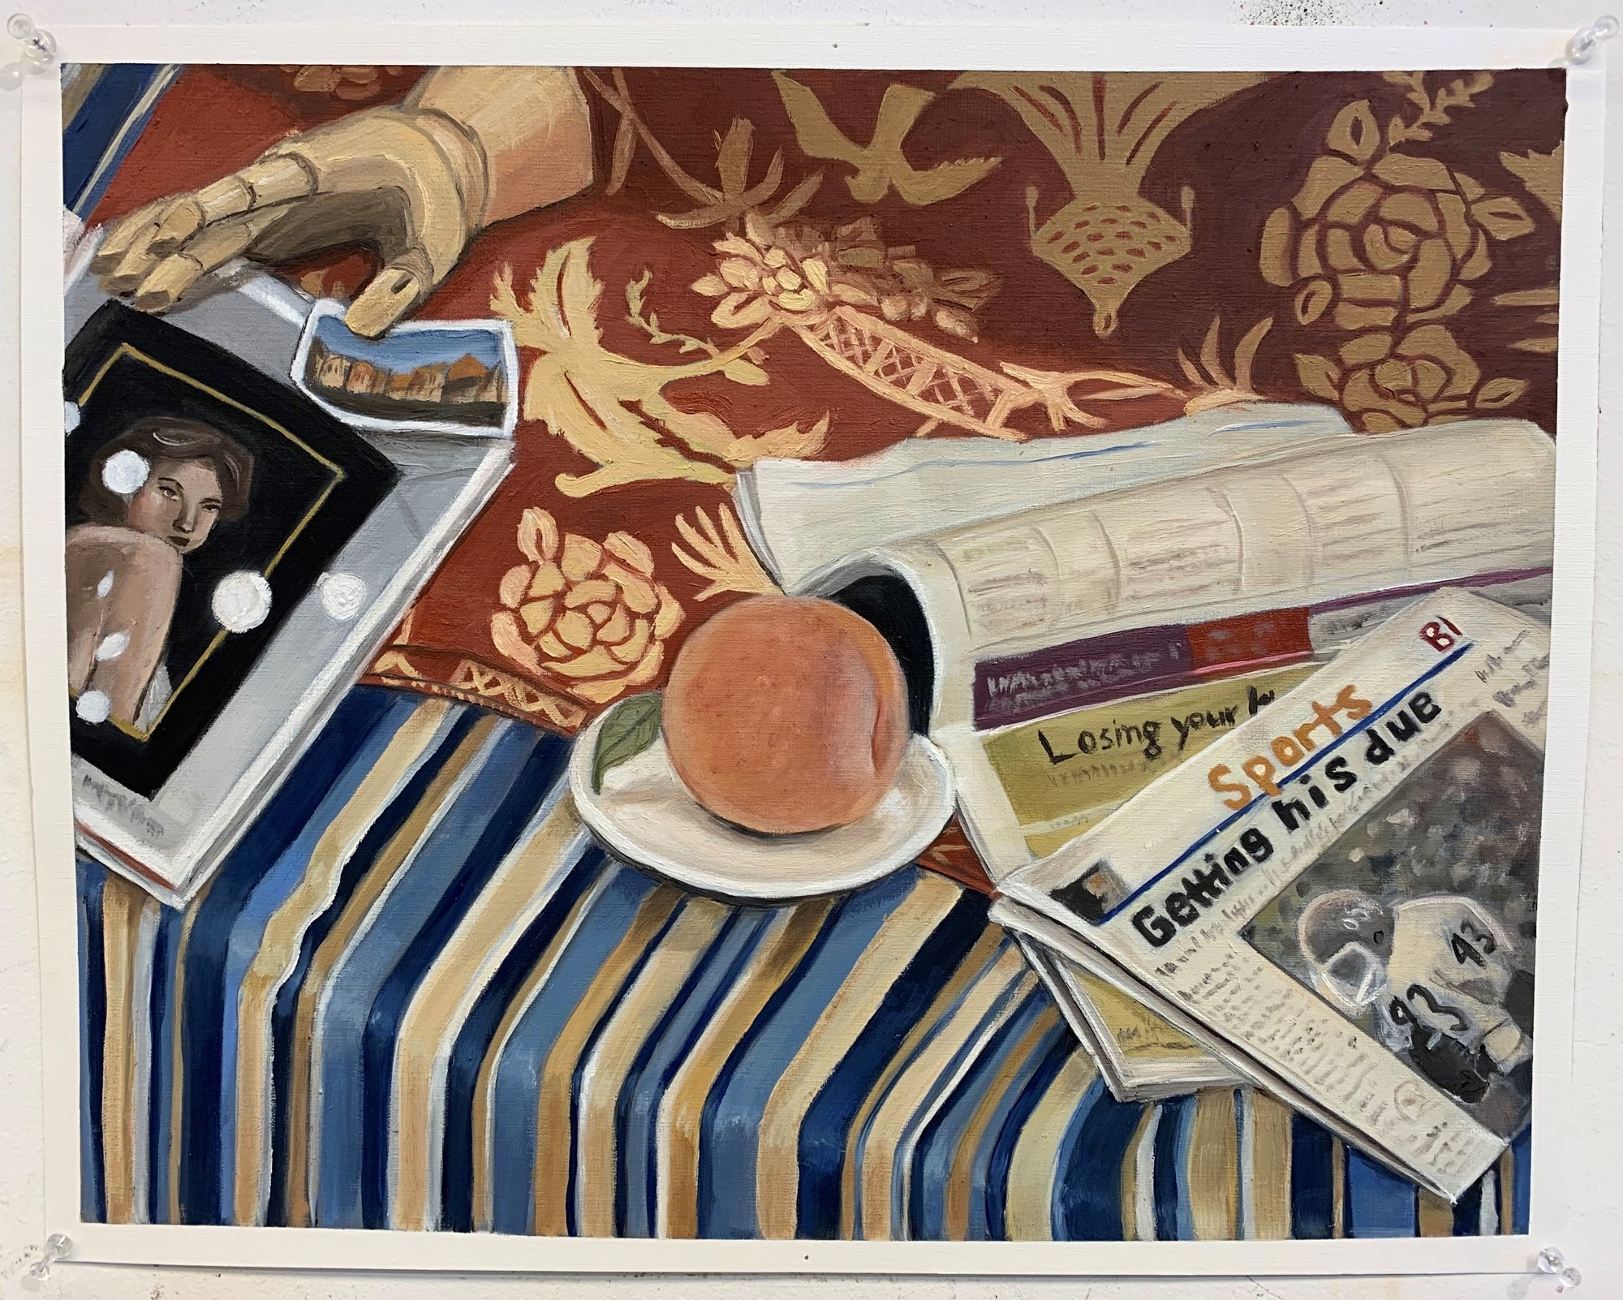

About the Author
Justice Rebmann
is a second-year student at OSU studying French and Creative Writing. Her three great loves are art, writing, and language, and after graduating, she hopes to work in translation and write fiction. She is the recipient of a Gold Key in creative writing from the Scholastic Art and Writing Awards. You can find her artwork on display at the Aspen Coffee on Western in Stillwater, where you might run into her nursing a lavender latte.

Pecking Crow
Jennifer Nabicht
I am a crow, a black bird that hides in the dark. I pick and prod my skin until it bleeds.
–
Crows are an adaptive species of bird. They strive in rural places to crammed cities where there isn’t room to breathe. They have the common sense to migrate or to simply move to a warmer spot in their territory. They know what is safest for their wellbeing and have the ability to fly away if need be.
–
I push myself deeper into the corner where my bed meets two walls. I peck around, fluffing up pillows for protection around me. My mom is screaming at me. I did something, but I cannot remember. All I see is screaming faces and fingers trying to reach out and curl around me. I dig my claws deeper into my nest.
–
The American Crow is considered a threat and pest to farmers. Scarecrows are built up, towering over the fields to scare the black birds away. Starving and frightened, crows scurry away. They also stay close to where they breed in attempts to protect chicks. Nests are built to be about a foot or so big and a few meters high in the trees. They put protection above other needs.
–
My mom stomps away, a giant, shaking my home. Something is taken from my nest. Punishment for what I said. My phone is snatched away. Any gravity I have is taken. My wings are clipped, stunting me from finding safety. I sink to the floor in silence. I couldn’t hear anything, and my throat strained. I cry. The more I lift my head up, the more my throat closes. A force wraps itself around my lungs, making me breathe in unnatural ways. The faster I hyperventilate, the less air my body steals. My head spins with the fan above me. I wish it would snap and fall. Something to take this away. Everything in me screams to run. I desperately flap my wings and fail. My brother is a child peeking into my nest. His big and dark blue eyes stare. My vision is blurred as I crow in pain. He continues to stare like I am trapped behind a thick glass. I am a marvel to him; he is a child interested in something familiar. My body waits for him to “poke” me. Waiting for the child to do something to see the bird act out. I grind my claws into the flat carpet. He turns away and into the hall.
–
I peck at my skin. Breathe. My claws scrape and gnash. Breathe. My hair is pulled, wrapped around these claws. Breathe. Still, I couldn’t breathe a single breath. I scurry and pick at my belongings. My nest becomes ruffled, a blanket of knick-knacks and books. Something to make me breathe. I look for a bird bath. A place to let the water drown me, to wash away this suffocation.
–
My naked body pressed the sides of the tub while water pelted me. Scalding water kissed my shoulders. I still couldn’t breathe. The water temperature increases and increases and increases. The feeling continues to stick onto my skin, like oil caked onto feathers. My nails claw up my arms and legs and down my hair. I pull and nip and pinch, but it is still there.
–
A bright shine catches my reflection. My bird brain wants to inspect and collect. I poke and prod the metal. My claws reach around, and I admire the razor. My head tilts to the side. It has about four blades lined up. Some hair clings to the corners, little specks of black.
–
I still couldn’t breathe, so the metal bit into my skin. My leg trembled as my lungs steadied. A relief flowed like red from my leg. I could breathe and I could think. A numb clarity filled my body. It reached into the crevices of the bathtub. The shower head aimed from above, raining on the small little gash.
–
I shook and flicked water from my feathers. My beak nuzzled into the towel. My little crow-feet waddled down the hall and back into my nest. I picked around, making it just so.
I bandage the little cut.
–
My nest caves a little inward, blocking out the unknown and unfamiliar. My body breathes and sinks. I am a little crow, and one more scab forms onto my skin, ready to be plucked.

About the Author
Jennifer Nabicht
Jennifer Nabicht is a senior at Oklahoma State University. She is currently majoring in English with a focus in Creative Writing and involved in Omega Phi Alpha, a community service-based sorority. She wishes to expand her education and achieve a master’s degree in library science and Information Technology to become a librarian to help those in need gain access to resources. Jennifer also strives to write about the struggles of weight, mental illnesses, and grief. She is currently living in Stillwater, Oklahoma with her boyfriend, and her dog Kiwi.

Striking Matches
Justice Rebmann
“To begin, begin.”
— William Wordsworth
My words trip and tap and clack,
but won’t click.
They stu-tter and stu mb l e,
into-each-other, into bubbles, push and pop,
flicker and go out— but not quite
yet— I won’t let them go out,
my little barking flames wild
with a desire to sing
words I can’t put to paper,
only seem to think,
for when I do, they shatter,
but maybe it’s the
sound
that matters.
Maybe it’s the sound that matters.
Flick-er, flick-er
burst bright—
but back again into the night
they fly, elusive. I fight for the ones that
stick, but my matches stick together like
candy and when I twist and pull, they
won’t come apart, like
the yearnings in me
that fight to be heard,
drowning in the narrow tubes of my heart,
and maybe I just need to start.
With sticky candy sticks
and a sticky heart,
until it all melts away into caramel,
and I’ll wonder why I waited so long,
when it really just took that long
to be okay with words
that bark
and shiver
before they begin
to spark.

About the Author
Justice Rebmann
is a second-year student at OSU studying French and Creative Writing. Her three great loves are art, writing, and language, and after graduating, she hopes to work in translation and write fiction. She is the recipient of a Gold Key in creative writing from the Scholastic Art and Writing Awards. You can find her artwork on display at the Aspen Coffee on Western in Stillwater, where you might run into her nursing a lavender latte.

How to Hold a Paintbrush
Gabriel Parker
It has been said that the spear was the first use of science fiction. Perhaps. If so, my room speaks to me of days when men sat around an open fire and plotted the death of the dinosaurs. Monsters, colossal behemoths walking among bearded oak trees, that treat you as nothing more than a fly beneath them as they walk among pits of reeking sulfur. Or maybe it tells of days when men sit around fires plotting the conquest of Mars, days when fire leaps up and gets caught in their eyes and lights their ideas. They grab hold of it, taste it, feel it burning their insides and then they act, with fire glinting from their fingertips and embers in their tongues. They change the world. They change the universe. That is what my room reminds me of. Days already happened and those not yet happened. Spears that have already buried themselves in graves of flesh and those that haven’t yet been thought up, those that still need the right man sitting around a roaring flame and thinking. Always thinking.
There’s a pleasure in a fire, a humanity in the unfeeling chemical reaction. Something ethereal, eternal. We may colonize the stars, set foot on every planet in the universe, tame the seas and melt the mountains down until every single one of us lives in a concrete cage, but never will we lose the serenity of a fire. We may forget, but it’ll spark back up one day when men need to think again, be quiet again. Breathe again. Then, with their eyes dull and the lights out, they will light a candle and set the world aflame.
These are the thoughts I have in my room, my quiet amber-green room whose walls burn like a cretaceous inferno. I find that people wonder at the vibrancy of it. They wonder how I can think with all that’s happening. I wonder how they cannot.
There was a time when I couldn’t think. I couldn’t breathe, I felt trapped inside my own room that was both mine and not mine. We were moving. My first room was green, not amber. A brilliant neon green that spoke of summer fields, cut grass, putting mats, and astro-turf. Fire? No this was power, precision: a line of eleven men working together like the pieces of a clock but with the explosion of a shotgun. But the gears must turn and the power must go. Great gashes of white crisscrossed my beautiful field, and like locks of Samson’s hair hitting the ground, one by one the gashes bled together, each strip of green seeming to pound the air as it died. Days, weeks, for months I was trapped in a room that had all my furniture, books, clothes, but it was not mine. It didn’t have me. As if all the hours I had spent in that room were baked into the color that hid behind a white veil. A bride soon to be married to someone else.
Tell me, how can someone move every year, every other year? I’ve heard that home is neither four walls and a door nor a button on your phone but a pair of eyes and a heartbeat. Yes, but it is a pair of green eyes and a red heart. Or perhaps blue eyes, or beautiful, rich coffee brown. But it has color and it has life. Color is life, a life all its own, a life that you give it. It speaks and tells you stories of all its brothers and sisters across the world if you let it. Tales of ash and coal and bleeding wounds in space or of days where you look out over the ocean and can’t draw a line between it and the sky and of bright baby’s cups and oven mitts and the colored spine of your favorite book. Colors tell you everything, and nothing. But a white room? It’s a blank canvas, a bride waiting at the entrance to the church, a brand-new baseball just from the factory. There’s no story there. Just anticipation. I found myself holding air between my pursed lips inside my un-room quite often. But never satisfaction. White doesn’t tell stories, it just waits for you to tell them, to find them. But they’re never there to be found.
My mother knew that. Of course, she knew that everyone innately knows that, they sometimes don’t know that they know, but they do. I find that perhaps the most rewarding activity is finding out what I know that I didn’t know I knew. For instance, I know my mother loves me. I’ve always known. But the hours she spent in my new room, my home, getting everything just right, layering the greens and the yellows so that they ended up as dinosaurs and green flames and the sounds of a Pterodactyl swooping high above your head. That’s love. Hours and hours she spent, and she sent pictures each layer. “More green? More yellow? Do they mix well?” You never know if they mix well until you live with it. You must simply feel a color to know the stories it tells, breathing it in. Therefore, I always deferred to her better judgement, her colored eyes. It was never good enough, never magical enough. One coat, two, three, five, eight. More and more until the feel was just perfect. Finally, it was right— like a mossy pond set ablaze.
Then as if a final tribute, a final act of brilliant artistry she named her piece. In bold letters above my door she wrote, “find your adventure”. Find it. Look around in your room and find it. Its there, shapes in the flames, burning in your mind. Find it.
So, I do. On nights when cicadas streak screaming across the night I open my window and I listen to their screams and I wonder what they scream about. I open up a blank page and I wonder. I wonder through the eyes of a bug or the cold Martian soil feeling the touch of humanity for the first time. I wonder through time, and places, cities that seem to have always existed and cities that haven’t even been started yet. Oh, the loveliness of a white page! It tells no story but what you dictate to it; so I look up at my walls and hear a story, then I write it down. Nights with nothing but the sound of keys playing their own strange little songs are possibly the most beautiful nights of all. Or days when I crawl out on the roof with another book to find the words of a dead philosopher, once again alive and weaving his web of literary sorcery there, on top of my house, in the middle of a neighborhood with no one to hear but me.
Then, with their words filling me up and running out my ears, I climb back inside my window, stare at those fiery walls, and I write. Taking the cup of my mind I shake until a little of that dead philosopher sloshes out. A little of him, a little of myself, a drop or two of my philosopher, teacher, from last week, last month and voila, a brand new story. That’s the kind of adventure I want, the kind of adventure that seeps through you like a drug. Don’t ask a writer where he’s been, ask him where he thinks he’s been. You’ll hear stories of cities more ancient than Machu Pichu and tales of wonders more beautiful than Gustave Eiffel could have ever dreamed of: great monstrous heads of stone buried broken in deserts, fireman who burn books instead of dousing flames, ravens that sit in the room with you cursing you from their glinting beaks; it’s all there. You merely need to know the writer. That’s the easy part, for writers are artists of a unique sort. Theirs is the only medium you can hold in your hands, feel each word, each brushstroke in your mind, under your roving fingers; and if you begin to read, really read, then you’ll suddenly notice that you’re not alone in your study or the easy chair in the back of the library or on top of your roof. No, you’re not alone, you have a man, or woman, there beside you telling you a story that they imagined. You’ll hear the gusto in their voice, or the cold contemplation that reeks through their breath. You’ll smell the fear in their sweat and in that moment, you’ll know them. There’s such intimacy in the written word dictated by a master. He can tell you so much about man, so much about yourself and not a single solitary fact about himself, yet you believe him to be your best friend. You would fully expect the man to walk up to you in a restaurant and start catching up like old friends. Those are the books you savor, the ones that you take the time to read through each course and then sit at the table, conversing with your host while you digest what he’s just fed you.
All of this because you learn how to find your adventure. Because you learn how boring white walls are. Paint them. You’ll find that it’s the best decision you can make. If you’re lucky enough to have someone who loves you, then you have it even easier, for love paints before you even have a drop-cloth down. Sometimes messily, but always gorgeously. So, find a painter, they live at the library and speak quietly at first, but sometimes, if you find a good one, they’ll sit down in a chair you didn’t know you had and take a long puff on an ancient pipe. Then they will start teaching you how to hold a paintbrush.

About the Author
Gabriel Parker
Gabriel Parker is an undergraduate at Oklahoma State University majoring in Creative Writing. He has had fiction published by FoxPaw Literary, Ripples in Space, and in an anthology by Grey Wolfe Publishing and poetry by BeznCo. He can usually be found deep in the bowels of the campus library holding back piles of books with one hand and typing away with the other. You can find him on Instagram @gabrielparkerauthor or online at gparkerauthor.wordpress.com.

Baby, I AM the view: A Portrait of Allie Mixon
Justice Rebmann
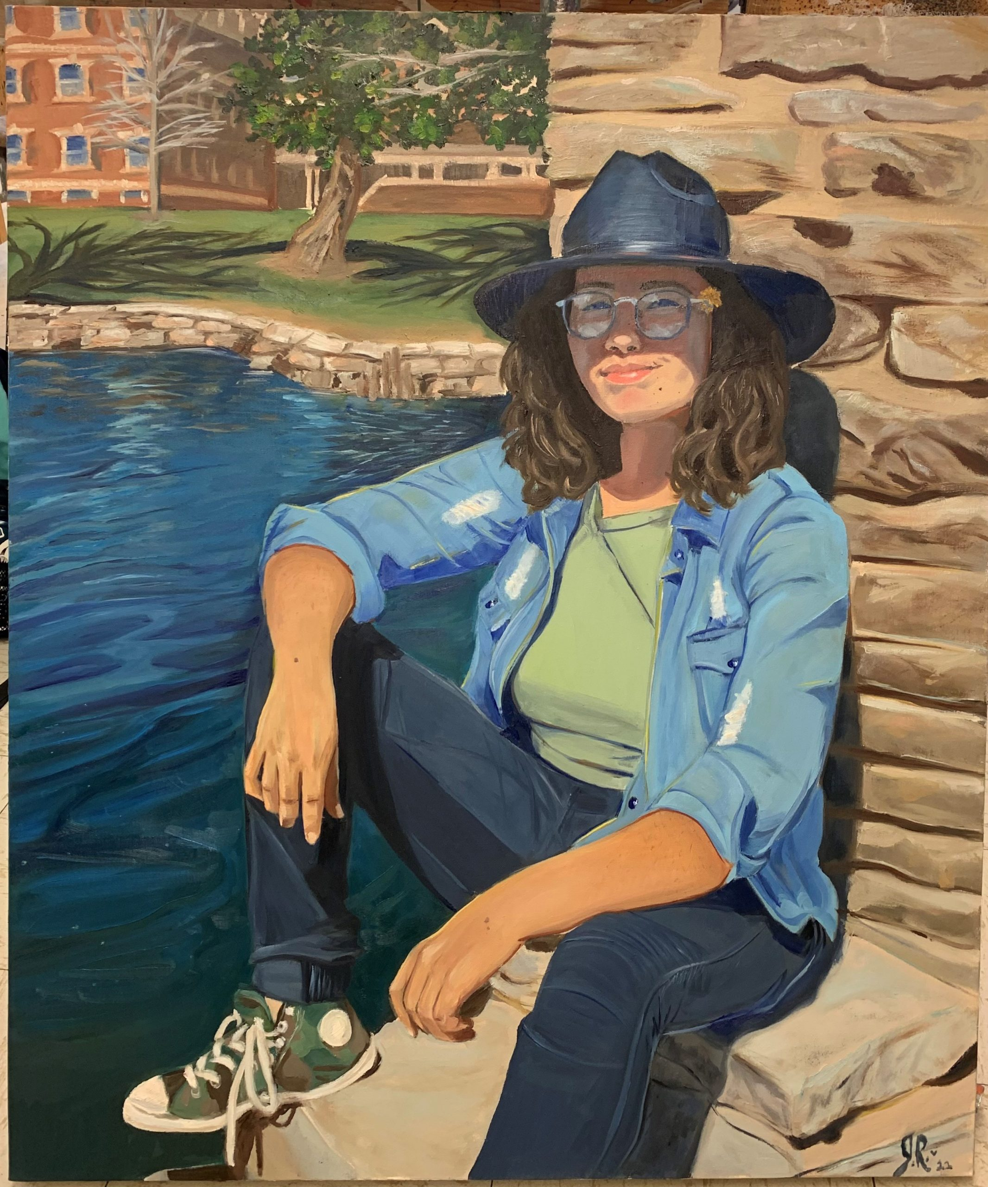

About the Author
Justice Rebmann
is a second-year student at OSU studying French and Creative Writing. Her three great loves are art, writing, and language, and after graduating, she hopes to work in translation and write fiction. She is the recipient of a Gold Key in creative writing from the Scholastic Art and Writing Awards. You can find her artwork on display at the Aspen Coffee on Western in Stillwater, where you might run into her nursing a lavender latte.

And You Were There
Aaron Ellis
When my eyes were blind, wound
tight by lashes, locked with twisted hair
like laces knotted twice to bind just right.
I heard your foot tapping.
When my brain alone in quilted corner
conjured living room lights burning bare
beyond the lines of lucid door aglow.
I swung up my feet and fell out of bed.
When my cheeks, elder now, remembered
tender the scratch of carpet tendrils there
beneath the drywall Earth we brothers shared.
I saw you sitting at your desk.
When my teeth chimed shy xylophone pings
for the tongue that, scared, swallowed words
unheard; the lips that, numb, said nothing.

About the Author
Aaron Ellis
Aaron Ellis is a senior at Oklahoma State University majoring in English Creative Writing. He is from Shawnee, Oklahoma, where he and his family have raised alpacas, trees, a few ducks, and two dogs named Punkin and Chewy. He can often be found reading comic books or playing tabletop games with friends and frenemies. After graduation, he looks forward to finally walking up the big steps of Morrill Hall.

Bitter Almonds
Kaia Mortensen
Favorite Party Nacho Bake
Recipe by Anna Jackson
Make in 20 minutes
Every party needs its salty snacks, and this recipe is always a hit! I’ve made these savory goodies for years, and they’ve never failed me. It took some trial and error to get them just right, but now they’re finally perfected. I can tell you with full confidence that this is a winning recipe! 😜
The first time I made this recipe, I was fresh out of college and on my way to a potluck at my new office job. I was bright-eyed and bushy-tailed, and I was sooo desperate to win people over. I’d tried making cakes, cookies, brownies—you name it! But nothing was up to my standards, and definitely not good enough to impress the bigwigs I wanted to if I had a chance at rising up in the business world. Suddenly, it occurred to me—I was going at it all wrong! Everyone’s going to be bringing sweets, right? And trust me, I love a dessert as much as anyone else with a baking blog, but there’s only so many sugary snacks someone can eat in one day without getting a toothache. Somebody’s gotta bring the salt, and I took it upon myself to do it!
When I got to the party, it was an immediate showstopper! I’m glad I made two, because the first one seemed like it disappeared as soon as I set it down. It was so good, my coworker came up to me to compliment my cooking. We got to talking, and now the two of us have just gotten married!
The issue anyone who has ever eaten nachos knows is that the cheese develops a film if you ignore it for even a second, which is why a bake is better for longevity. No one wants to pull
lukewarm cheese off of soggy chips. A bake with easy-to-serve portions eliminates this problem while making you stand out for creativity. Just ask my husband! 😄

Easy Coffee Cake
Recipe by Anna Jackson
Make in 45 minutes
Coffee is an essential in today’s world. I drink it every day, and sometimes even more than especially once lately, ha ha. It always feels like a shame to have coffee without something to eat, though, so here’s a low-effort coffee cake recipe to pair with your drink. Pay no mind to the amount of time it takes to make it—only about five minutes should be spent putting it together. Then you can spend forty minutes waking up and brewing your coffee, or if you’re smart, you’ll make it the night before you need it. I usually forget to, but I make this so often, I almost always have it on hand anyway.
I figured this recipe out a few years ago, and it’s been a real rock in my life ever since. All good recipes are either passed down or stem from a moment of desperation, and this definitely falls into the second category. Every baker knows what it’s like to be startled with news of surprise guests coming to visit and realize you’re low on ingredients. It’s a nightmare! There’s only one thing to do: dig out whatever ingredients you have and cobble something together. Sometimes this ends disastrously, but other times it ends in a delicious accident.
Anyway, imagine my surprise when my husband told me one Sunday mid-morning that his mom would be coming over after lunch! I was in desperate need of a shopping trip, and everyone knows I couldn’t very well send him to pick up ingredients, LOL! But with some basic ingredients I always have on hand no matter how dire my cupboards are, I managed to scrounge together this recipe. With a few tweaks over the years, it’s turned into a favorite of mine.
To any coffee snobs out there: I’ve been playing around with what to use to really make this recipe shine, and I’ve found out that Guatemalan and Colombian beans pair really well with the cinnamon taste! I wasn’t much of a coffee drinker until recently, so I’ve had to learn this on the fly, but I’ve grown very fond of it! Happy coffee drinking!

Mom’s Chicken Noodle Soup
Recipe by Anna Jackson
Make in 30 minutes
Life’s hard sometimes. I’m not making any bold statements by saying that, I know, but it’s true. Sometimes life really gets you down in the dumps! When that happens, I always find myself craving something simple, soothing, and familiar. It can be fun to lose myself in a complicated recipe to destress, but I’ll admit I don’t always have the energy for that. That’s where this recipe comes into play—it’s just as easy to make as it is tasty, and that’s exactly what I need some days.
I’ve said before that all good recipes are either happy accidents or family heirlooms. This one falls firmly into the latter category. When I think about growing up, I always remember my mom making me this chicken noodle soup when I was sick. My grandma made it the same way when I visited on cold winter days. If I had to give childhood a taste, it would be this soup.
Of course, it wasn’t only reserved for when I was missing school for sickness or for snow. My mom had this knack for knowing just when things were getting hard. Before I even began to express my anguish, there she’d be: soup in one hand, box of tissues in the other. I’ll admit, I spent many evenings crying into the bowl, my mom’s hand a firm, soothing presence on
my back. I was always grateful for it, but I feel like I never expressed it enough. I definitely should have appreciated it more when I had it.
I’ve only made this soup for other people a handful of times. It is by no means a go-to for entertaining guests, and my husband always complains that the broth is too creamy (what does he know about cooking, though, really?), so I don’t get a chance to break it out regularly at all. More often than not, I only make it if my husband is out with his friends at night, because if I say I’m making it for him, he orders delivery, ha ha. Men, right? There’s no winning!
Anyway, it doesn’t matter who I make it for, because now I’m sharing it with all of you. I hope this recipe can bring someone the comfort it always brings me. Thanks, Mom, for sharing.

Egg Roll in a Bowl
Recipe by Anna Jackson
Make in 25 minutes
Before I begin—I’m terribly sorry for the impromptu hiatus! I had all sorts of plans for a recipe for a creamy guacamole that complements any Fourth of July barbeque perfectly, but it just wasn’t working out for me. I’ll post it as soon as I can, but unfortunately, it might end up being more suited towards Labor Day at this point. I hope this isn’t too much of a disappointment to anyone!! I know I received a couple comments asking after it, which I appreciated. It will come!!
Lately, I’ve been having a lot of trouble keeping most food down. Combined with completely nonsensical cravings (seriously, who thought bananas and bacon would be a good combination? Me, apparently!), I’ve been having a heck of a time coming up with anything that sounds appealing to anyone who doesn’t happen to also be pregnant. My husband has been
complaining about my “creativity” in the kitchen, but I don’t see him cooking! Though I don’t mind doing it myself. I have a funny feeling that he might just burn the house down if he tried, LOL.
This recipe solves all of those problems, while still being tasty and easy to put together. A quick meal of an egg roll in a bowl makes for a good source of protein, all while being tame enough on the taste buds that it isn’t too upsetting for my queasy stomach. Of course, the spice level can be adjusted for taste—Lord knows I make it spicier than this when I can stomach it—but this recipe has it with juuust enough included so that it still has flavor while still being gentle on the stomach. Next to the combination of rice, chicken, eggs, carrots, ginger, and cucumber, this is the perfect meal for anyone in need of easily digestible protein-heavy foods!
Here’s a little tip, from one cook to another: if you’re short on time or patience, try using a rotisserie chicken from the grocery store instead of cooking one yourself! It’s just another way to take a load off your shoulders, rather than getting everything together yourself.

Dark Chocolate Espresso Mousse Cake
Recipe by Anna Jackson
Make in 2 hours 30 minutes
Sometimes, the tastiest recipes have a big time commitment. A mousse can easily take upwards of five hours once time spent waiting on things to set is taken into account, and while it could certainly be worse (you’re not actively baking the whole time!), it’s a lot to ask for. This recipe is by no means quick, but it’s much more doable in my busy evenings than a 5+ hour time commitment. By cutting a few corners, the time can be functionally halved—but don’t worry, the taste won’t be compromised!
I know a mousse can be complicated and scary, but trust me when I say this one will be a piece of cake—literally! I usually enjoy a glass or two of red wine as I’m making it, and another two once it’s done, ha ha.
I was not at all a dark chocolate person until my early-to-mid-twenties. “Why would I eat chocolate that isn’t even sweet?” a 20 year-old Anna might say. I preferred milk through and through, and would sooner have picked a white chocolate over a dark chocolate. While I still love a good milk chocolate, I’ve definitely changed my tune since then. The introduction of various wines to my palette certainly had a hand there! I’ve spent countless evenings with a glass of wine in one hand and dark chocolate in the other. It is splendid.
This is another recipe I don’t make often. Thanks to the long prep time and my husband’s embarrassingly unrefined palette, it’s more of a hassle than it’s usually worth. He doesn’t seem to have ever moved past the barrier I did into liking foods with a bit of bitterness, and he’d much rather I spend my time on things he deems more “worthwhile.” Joke’s on him, because any girls’ night I have features this as a staple! Sometimes I’ll even make it for myself on evenings when he’s out, just to have a little treat to pair with whatever I’m surely drinking that night. Whether it’s for celebration or consolation, it hasn’t failed me yet.

Pan-Seared Filet Mignon
Recipe by Anna Jackson
Make in 40 minutes
Steak is a staple of any good date night. I swear, there’s something in the way men are wired that makes them crave it like nothing else. They’ll be rooted firmly to the couch,
complaining about how long dinner is taking, their hard days punching numbers at their cushy desk jobs (even though you work the same hours!), and just about everything else under the sun, but put a steak on their plates and they’ll be all, “yes, my beautiful wife, thank you, I appreciate you so much, I’m so sorry I’ve been a total piece of work, I know it’s not your fault that the Eagles lost, let me make it up to you and take you to Paris/Rome/insert-romantic-city.”
Or, well, maybe not. My steaks aren’t quite that magical. A girl can dream, though, right?
Even if they aren’t actually miracle workers, these steaks come pretty darn close! Paired with a good side of veggies, it’s easy to forget you aren’t actually in a fancy steakhouse. I’ll let you in on a little secret: it’s all about the marinade. Searing it with olive oil, a blend of spices, and those side vegetables I mentioned ties everything together beautifully. It makes it juicy and absolutely decadent, I promise. Bonus tip—stick it in the oven with the veggies for just a few minutes if you’d like it cooked a little more thoroughly! Nothing too long, of course, but it does make a difference. If you’re like me and don’t necessarily want your steak to bleed like it’s still got a pulse, I’d recommend it. 😉
On the note of other red liquids you hope to see with any good steak, pairing this with a good red wine does wonders! If you’re interested in that, I might recommend my Dark Chocolate Espresso Mousse Cake uploaded last month for dessert. Talk about another good pairing! If you try the two together, I’d love to hear about it in the comments. For that matter, if anyone sees any real magic from these steaks, I’d love to hear about that too! I’ll be sure to do the same. I’m hoping this time I might see the miracle I’ve been missing. Cross your fingers for me!

Perfect Gingerbread House
Recipe by Anna Jackson
Make in 3 hours
I’d like to start this recipe by stating that no, your gingerbread house might not take quite three hours. Honestly, you shouldn’t expect it to, unless you’re as much of a perfectionist as I am and are determined to turn each gingerbread house into your dream house. I’ll be blunt—this recipe takes time, patience, and practice to get right. That being said, I always feel like the end result is worth it. It’s both beautiful and tasty—what else could you ask for?
Growing up, I made plenty of gingerbread houses with my family. They were never nearly as elaborate as the ones I make now are, but the sentiment remains. I always made sure to put a little gingerbread family inside the house, even though they wouldn’t be seen with the roof on. The windows were nothing more than squares of icing marking the impression of a window, but that didn’t matter to me. I loved the idea of a perfect family enjoying their beautiful house, even behind closed doors where people couldn’t see them. I made sure to decorate with all the care and tenderness a child could muster just to make the perfect house for each and every gingerbread family. I always liked to imagine the gingerbread house was my house, in a way. I suppose I have never quite grown out of that.
Once you really get into building a gingerbread house, it’s easy to lose yourself in it. It’s a science, in a way; you have to make sure the walls are all firm enough to hold their own weight, as well as the weight of the other walls, the roof, and the decorations. If you’re planning on doing what I didn’t as a kid and make a see-through window, it’s a better idea to cook the gingerbread with a cookie cutter in the middle than to attempt to cut it. (Tip: fill these with melted sugar for a glassy look!) Striving for perfection is never-ending, but the result can be worth it.
The saddest part of a gingerbread house is how it ends. There’s two options: break it apart and eat it, or let it grow hardened in the air. I can never bring myself to break it. My husband has never seemed to have a problem pulling off the pieces, though.

Mug Cake For One
Recipe by Anna Jackson
Make in 10 minutes
Bigger doesn’t always mean better, and this individual mug cake is the perfect treat for a night alone. Not only is it the perfect size to keep to yourself, it’s easy enough to make a second if your sweet tooth is out for vengeance. You can vary the number of white chocolate chips for a sweeter effect, too, or leave them out entirely if you want to focus on the lemon’s tang. All in all, it’s the perfect individualized dessert.
I know, I know. This is way simpler than most of my recipes, and there are hundreds of other mug cakes on the internet that are much more efficient to make than this one. Even so, I can’t keep myself from making things from scratch when I can, and I feel like the few extra minutes of effort makes a big difference in the end. Take the lemon peel on top, for example: it’s not necessary, per se, but it certainly adds a little flair that really brings it to life. Plus, why not put in that effort for yourself, right? A little indulgence never hurt anybody, and if that indulgence also adds a bit of a zing, well… All the better, right?
Despite being a staple in many kitchens, I feel like lemon is an underutilized flavor, which is a real shame! It can go on meat dishes just as easily as it can be a component in a cake. Its sour tang and sweet flavoring makes it a tool that’s incredibly flexible. It’s multidimensional, you know? There’s a lot going on with lemons that goes terribly underappreciated.
When I make this for myself, it’s usually on an evening when my husband has gone out with friends and I’m left alone at home. It’s the perfect treat for times like that, and even better: it’s so easy to clean up that no one ever needs to know. Just a few little measuring cups, a grater, and a mug, and you’ve got a dessert that’s delicious—and deliciously private. If you’re worried about any comments from certain people in your life regarding your eating habits when those people have a much more severe proclivity towards sweets, this is a great option. I’d definitely recommend it.

5-Alarm Chili
Recipe by Anna Jackson
Make in 45 minutes
This is a little out of my comfort zone, but it’s a recipe I made recently, and I found it to be exactly what I was craving. Sometimes when you’re just seething, all you want to do is scream. The second best option, in that case, is to eat some extremely spicy food. This, my friends, is exactly that. If you aren’t crying by the end of this, you haven’t done it right. If you’re lucky, it can mask your real tears of anger in a pinch!
I rarely have a chance to make spicy food, because my husband refuses to try it and then becomes grumpy with me when I have nothing else prepared. Sorry, I didn’t realize I’m supposed to cater to his whims and his alone! More often than not, I just make whatever he likes and learn to like it myself. I find ways to make it interesting, of course, but it can be dull and repetitive to follow someone else’s tastes when I know I’m capable of making so much more.
Today, I’m not paying any mind to his tastes, though. He can suck it up, quite frankly. 🙂
Usually, I give recipes a few more test runs before I post them. I haven’t had a chance to try this before, though, and I’m not sure if/when I’ll be able to try it again, so it’s going up now. I might upload an updated version of this recipe in the future if I make it again and decide it needs changes. As it stands, this recipe is pretty @!$#ing solid for a first attempt, if I do say so myself (which, of course, I do).
Another definite benefit to this recipe is that I was able to make it without much struggle even despite my freshly-broken wrist. Stirring is not too difficult with my non-dominant hand, and if that’s really all I need to do, it’s easy enough for beginners in my book. I’m certainly looking forward to the removal of my cast, even though I’m sure it’ll change very little in my life. Ah, well. Life happens, I guess. Hopefully, I’ll post my next article on something I’ve got a little more experience with and after I’ve had my cast removed.
Fingers crossed! (To the best of my ability right now, of course.)

Cheesy Garlic Mashed Potatoes
Recipe by Anna Jackson
Make in 50 minutes
Now, if you’ve been following my blog for a while, you know I’m not usually one to take requests for posts unless I already have a recipe prepared. It’s nothing against any readers, though, I promise! I’m just a busy woman, and cooking for two is enough work without cooking for two hundred, ha ha. But I received many sweet comments on my last post asking for some sort of comfort food, and… Well, I wasn’t exactly going to say no, was I? Especially because they all seemed to come from a place of concern for me. I appreciate the gesture!
I’ve posted one of my mom’s recipes before, but here’s another one inspired by her cooking. It’s not quite how she makes it (it’s just impossible to make things the way we remember, isn’t it?) but I think it serves its purpose well enough. Because I can’t make it exactly the way she did, I’ve put my own little twist on it. Let me tell you: roasted garlic makes all the difference. I’m serious, you can’t go without it.
Despite the long recipe time, the prep time is really only something like ten minutes. The rest of the time is spent cooking the potatoes, so you don’t have to actively look over them as it’s happening. You’re welcome to attend to them, though—it’s easy enough to look busy while standing in the kitchen, even if you’re not actually doing anything. If you’re like me and the kitchen becomes something of a safe haven while you’re cooking, it can give you a full hour’s excuse to stand around with little more than your own thoughts for company. Sometimes that’s not ideal, but sometimes it’s nice to have that time to think, you know?
Once again, I’m sorry this recipe took a while to post. I received many worried comments, and I really appreciate them, but I’m fine, I promise. My wrist is healed enough now that I can comfortably attempt this, which was really what caused the delay. Mashing potatoes can be pretty strenuous, huh? Don’t worry, though: it’ll all turn out well, I’m sure of it. I’m hopeful, at least.

Raspberry Almond Blondies
Recipe by Anna Jackson
Make in 30 minutes
Friends, please join me in a recipe that I’ve been looking forward to a long, long time. It’s something I’ve made on many occasions, but this particular instance, I’ll be using a special, secret ingredient. I won’t say what it is, but you all are a batch of smart cookies. I’m sure you can figure it out. 😉
These raspberry almond blondies are a surefire hit every time. They’re easy to make, and they’re just the perfect level of sweetness. In fact, they’re sweet enough that you can add small but potent amounts of other ingredients, and all anyone will be able to detect is a hint of bitterness in the almonds. I love almonds, and you absolutely can’t go wrong with raspberries in any dessert. It’s just a shame I won’t be able to eat today’s batch!
I’ve been making this recipe for nearly a decade now, and I’ve only ever adjusted it slightly to taste. It’s hard to screw up! If you’re a big fan of almonds, you can add a little extra without overbalancing it. If you’re a raspberry person, a little raspberry puree on top after it’s out of the oven can do wonders. If you’d like to really go beyond and you have it accessible, marzipan can elevate it in fresh, unexpected ways. There really isn’t a way to go wrong with it! Today, along with my special ingredient, I’ll be working in all of these ingredients to some extent. I’d like to make the flavors really burst. I think I might add a little extra sugar to taste as well, though that is by no means an expectation. The sugar content is typically perfect—it’s only when the almonds are especially bitter that a higher dosage might be necessary.
These are one of my husband’s favorite desserts, and it’s one of the few things we agree on. It’s the only thing that makes me a little disappointed that I won’t be able to try this super-charged batch, but I can’t stay upset for too long. I’m afraid I don’t particularly want to try this secret ingredient. I’ll ask him how it tastes, but I’m not sure he’ll answer. Usually he just won’t ever shut up, but I have a funny feeling this time he might. I won’t complain.

Angel Food Cake
Recipe by Anna Carter
Make in 1 hour
Is there any food more satisfying than angel food cake? Its light, fluffy quality just feels like a victory, and I’ve always been fond of the fact that it’s rarely glazed or decorated with anything beyond a simple dusting of powdered sugar. There’s something so inspiring about a cake that doesn’t feel the need to hide behind the excessive sweetness found in icings. The dessert speaks for itself, and it says, “I know exactly what I am.” Isn’t that beautiful?
Angel food cake always felt very “adult” to me as I was growing up. It was only ever served at big events, and so it became something of a delicacy to me. It’s for that reason that I bought myself an angel food cake the day I moved into my first apartment. It wasn’t anything fancy; it was from a grocery store bakery, so it wasn’t mindblowing by any stretch of the word. Even so, I sat there on my floor surrounded by moving boxes and ate every last crumb! For the first time, I felt like a real, proper adult.
That experience, as well as the openness of angel food cake, is what motivated me to make it now. I’m in a bit of a transitional time in my life, and as I found myself surrounded by moving boxes in my new apartment, it just felt fitting!
Also, I’d like to apologize for my absence over the past few weeks. I have been just so busy! Living single for the first time in the better part of a decade takes some getting used to, and I’ve moved far across state lines. It’s all very big and exciting! If you follow my blog, you might know my latest recipe before this was for some nice raspberry almond blondies. I’ve had a few comments ask how they were received, and I’m pleased to announce they served their purpose beautifully. I still won’t reveal the secret ingredient—you know what they say about magicians!—but I now know I can keep that in my back pocket in case of an emergency. You
never know when you might need the support of a dessert that’s absolutely to die for. In that case, have no fear—they were killer!

About the Author
Kaia Mortensen
Kaia Mortensen is a senior at Oklahoma State University. They are majoring in Theatrical Design and Technology and minoring in English. After graduating, they hope to create costumes for professional theatre companies. They are from Flower Mound, Texas and currently live in Stillwater, Oklahoma.

Euphorically Stoned Head
Amaya Banks
I see words of affirmation waving at me as they play tag in the
clouds. Penny, the sun, and the warm breeze of the day serenely
keep me company. Stress couldn’t make it, fear canceled last minute,
and anger simply didn’t show up. My mind is one with nature, I have
seasons too.
Warm, Cold, Windy, Still.
Rain, Sun, Snow, Drought.
When the weather changes people go where they will be comfortable
and unbothered. They either go inside or outside. I’ll just be here.
I miss my friend but she is now nature, so we have synced.
Coral Honeysuckle to nourish, Bee Balm for fun.
Everything is beautifully real and here in my face.
I no longer see the playful words.
But they have left their mark on me.
I saw the world differently just like the world probably sees me.
You have the choice to view life on earth as heaven or hell.
Is it wrong to allow earth to help you escape the world?
Do you think I care where you’ve been or what you’ve done?
Do you really want someone who would leave when they saw the parts you keep hidden?

About the Author
Amaya Banks
Amaya Banks is a senior at Oklahoma State University majoring in Sociology. After graduating, she plans on becoming a social policy analyst whose primary focus will be to advocate for minorities and neglected social groups in a diverse number of communities. She also has a passion for writing and plans on utilizing her skills to enhance her future career.

Artemis
Justice Rebmann
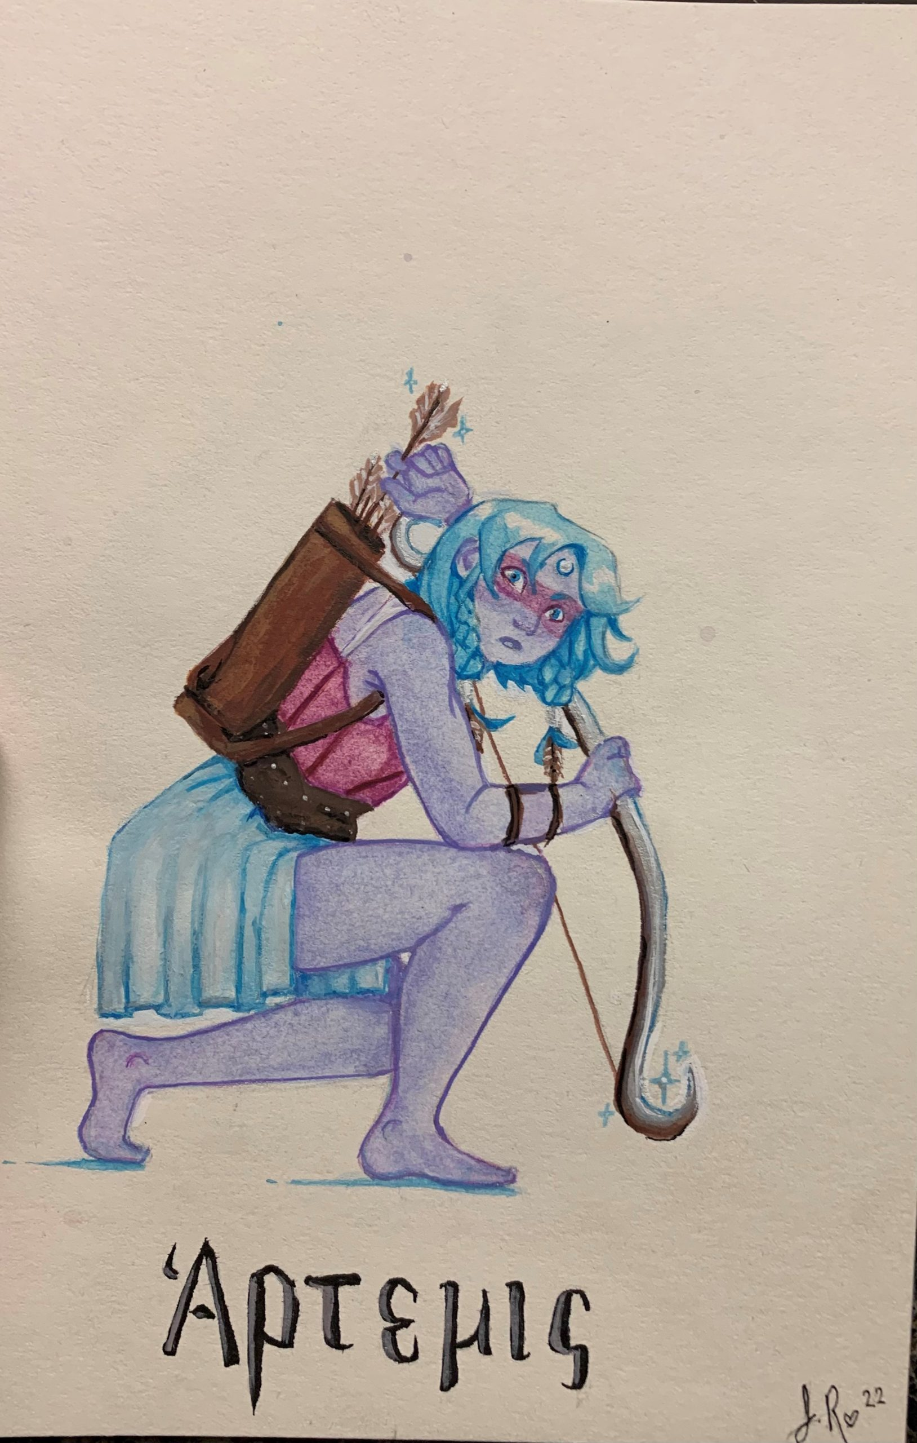

About the Author
Justice Rebmann
is a second-year student at OSU studying French and Creative Writing. Her three great loves are art, writing, and language, and after graduating, she hopes to work in translation and write fiction. She is the recipient of a Gold Key in creative writing from the Scholastic Art and Writing Awards. You can find her artwork on display at the Aspen Coffee on Western in Stillwater, where you might run into her nursing a lavender latte.

Elegy for Pearl Bryan
KD Leigh
A girl’s head floats, ghostly,
Rotting softly, in still water,
Face colorless, contorted,
A scream of ancient horror.
(Two men and a woman enter.)
Hair wisps, rise and fall,
Fringe on Death’s tattered cloak,
Strands suspended, umbilical cords coiling,
round a lineage of crumbling stone.
(Two men leave.)
Stretched over a skeletal frame,
Skin surrenders to bone’s motherly swell,
The stench of three lives unled,
Lay lost at the bottom of a well.
(A woman's headless corpse,
follows behind them.)
Heavy veins, a noose in afterbirth,
Wilting like a trail of love-lies-bleeding,
And a girl approaches pearlescent eternity.
Eyes, like shells, pried open and pleading.

About the Author
KD Leigh
KD Leigh (she/her) is a sophomore at Oklahoma State University. She is pursuing dual degrees in English and History and, as a result, spends much of her free time writing essays. Currently, she works as a tutoring consultant for the OSU writing center where she edits other students’ essays. In the future, she hopes to attend graduate school, write even more essays, and continue pursuing her goal of publishing original poetry. In her work, she explores topics such as religious trauma, sexuality, leftist ideals, and mental illness. She currently lives in Stillwater, Oklahoma in an apartment overrun with roommates and possibly too many cats.

Deceptive Cadence
Corben Horten
“Charlie,” my mother says over dinner. “Pass the salt.” I watch my brother’s long, delicate fingers wrap around the saltshaker as he presses it to my mother’s short, stubby digits. My brother’s hands were made to play the piano. This is what my mother tells him in rapturous whispers. She loves music but lacks the finesse with which to evoke melodies from those ivory teeth like Charlie can.
“Vic,” my father says to me as he watches his knife cut apart the steak on his plate, “eat your food.” I can’t—I know that the white flakes sprinkled on the meat are really just salt mixed in among other seasonings, but every grain reminds me of that euphoric look in Charlie’s eyes as he stared into open air, overwhelmed by the substance I saw him devouring. So, I don’t eat. It’s easier to pick, to play with, to push around. My father chews on in silence, unbothered.
A week later we sit in the soft, dim light of an immense auditorium as Charlie plays for the stunned audience packed into every red-cushioned seat available. I read the brochure that pictures my brother’s dazzling smile on the cover. The words are hard to make out and the sound of my brother’s fingers making the piano cry wash away the melodic chords I try to hold onto.
Charlie finishes his last song with a crescendo of music that ends in the notes of our parents’ uproarious applause. He bows to the entire congregation of people who have assembled here. They cheer his brilliance, and I see the prideful satisfaction in his eyes as he takes it all in, his chest swelling with that same rapturous bliss that I see played over and over again in my mind.
He is a god to these sycophants. I alone am the unbelieving; knowledge has stolen my faith in him.
I excuse myself and find the bathroom. The vision of his grin is the only thing I can see as I vomit into a toilet while the distant percussion of all those clapping hands cheers me on as my stomach contracts for an encore.
“That was wonderful, Charlie!” My mother’s fat, trembling fingers caress his flushed cheek.
“Vic,” my father says quietly to me as he pulls his phone out of his pocket. “Take a picture of your mother and brother.” I reach out and accept the phone from him, careful to avoid the hairy, calloused fingers that speak to my father’s strength as a man. I watch him weave between silk-covered tables across the large, fancy dining room in pursuit of a waiter carrying a tray of champagne glasses.
Though I earned my driver’s license eight months ago, he will drunkenly refuse to let me drive us home. My mother will whisper to me, “It’s just how he is. Now fix the seat cover for your brother; I don’t want his suit to get dirty.” I will sit silently as my mother makes sacrifices at Charlie’s feet while my father struggles to stay in our lane. “I took on a few extra shifts this month to pay for your plane ticket to Albert Hall. I’ve already spoken with your instructor, and he’s bought his ticket for the 18th of next month, so he’ll be able to fly with you and help you navigate London.”
She will have completely forgotten that I asked for a new winter jacket two days ago since my last one was ripped apart at the seams in our washing machine. This will remind me of how she bought a new suit for his eighteenth birthday a few months ago but couldn’t afford to pay for the cost of my class’s field trip two weeks before that.
Right now, though, I try to fit my brother and mother within the view of the camera. “Oh, Vic,” our mother says as her hand flutters to the curls of her short hair upon seeing the phone in
my raised hands. “Give me a moment.” She pulls a tube of red lipstick from her small purse and applies it to her lips before making small popping noises with her mouth. Hidden, Charlie rolls his eyes in annoyance. My finger twitches to touch the screen of our father’s phone and capture this rare break in his façade. But then our mother turns to him, and he is her son once again.
I freeze this moment in time for our mother to look back on until the day our father will throw his phone in frustration and despair and lose this unsaved memory forever. She is smiling, right arm wrapped around my brother’s waist, head pressed to his shoulder. He grins lazily, hands in the pockets of his suit pants that our mother worked sixteen hours of overtime to afford.
They separate when I lower the phone. It’s difficult to tell who pulls apart from who. Our mother, who envies Charlie’s gift and puckers her lips at his lack of wonder for the music he plays? Or Charlie, whose eyes have been caught by flesh swaddled in a red dress across the room?
No one speaks to me. I stand in a dim corner, a single Bluetooth earbud hidden by long strands of hair that my mother occasionally catches in her hands and tuts at as if she can cut them with a scowl. Drums, loud and fast, ride along the strings of a guitar while the raw voice of a man sings about a wasteland of corpses walking their dogs and taking their kids to school. My brother once saw my phone’s screen as I listened to music, and before I could stop him, he’d leaned close enough to read the song’s artist and title.
A few hours later he had found me in my room and said, as if he’d just checked the weather outside, “They’re pretty trash.” I’d stared at him until a corner of his mouth lifted in a smirk and he returned upstairs to his own room.
The night ends. Drunken father, sacrificing mother, silent me. Charlie’s hands twitch in his lap on the drive home, and I watch the tips of his fingers bounce against one another from the shadows. Our father pulls into the driveway, nearly hitting the curb, and kills the engine. He stumbles out of his seat and our mother quickly exits the car to help him walk inside to bed despite his protests.
Charlie and I sit in the car and watch them enter the house. For a moment I feel as if I do not exist; right now, the world has turned its eyes on Charlie and waits for his next move. “I’m tired,” he tells it as he opens the car door. “Think I’ll head to bed.” He shuts the door behind him and follows our parents inside.
I sit separated from the world, watching as if from behind a pane of glass. I am a spectator. Nothing more.
I’ve grown accustomed to his routine. Play the piano. Stun the audience. Lavish in their praise. Act the prodigal son.
These are the things he lets people see. But his secret knows me, and it reels me in towards his darkened room at three in the morning where no one is left to witness him, to look to him like a deity. I push open the door and step into darkness. My shaking hand flips the light switch, and I find him sprawled on his bed in a puddle of his own drool. His open, unblinking eyes stare at me. There is something missing there, stolen by the glaze that has overtaken them.
Charlie hadn’t realized I was there when he inhaled those lines of white, crystalline powder on his desk and threw his head back in rapturous bliss so long ago. I’d watched from the darkness of the hallway outside his barely open door as he sniffled and shuddered, finally free to relinquish the Lieto fine he so often played for others. He didn’t know that with each shuddering breath and every sigh of ecstasy he was shackling this moment to my mind forever and making me its prisoner.
I gag him so that his body is forced to eject the poison he fed it into the toilet of his bathroom. Unconscious though his mind may be, his body recognizes this pattern. It doesn’t fight me as I force it to expel even more of whatever he put into it.
I clean him up and place him back in his bed, too tired to care that he’s still wearing the suit from his performance. Besides, removing it would risk the possibility of questions, and I wouldn’t be able to offer any answers.
Later while lying in my bed, I hold my hands above my face to examine my fingers: the long, delicate digits my brother and I share, though mine have a bit of the meat of my mother’s. They are not fingers meant for piano, and I am able to breathe as I think this thought to myself. They are not fingers like his.

About the Author
Corben Horten
Corben Horton is a senior of Creative Writing at Oklahoma State University. After graduating, he plans to attend graduate school to pursue a doctorate in Creative Writing in order to teach at a university. His desperate, impossible dream goal is to become a published author in the fantasy genre in the next six years, and he’s currently working on a manuscript that he hopes will be accepted for publication after it’s finished.

Still Life With Cacti
Justice Rebmann
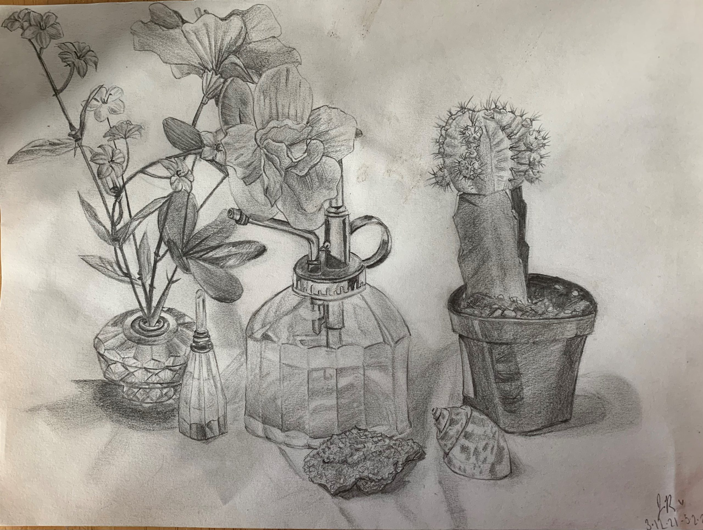

About the Author
Justice Rebmann
is a second-year student at OSU studying French and Creative Writing. Her three great loves are art, writing, and language, and after graduating, she hopes to work in translation and write fiction. She is the recipient of a Gold Key in creative writing from the Scholastic Art and Writing Awards. You can find her artwork on display at the Aspen Coffee on Western in Stillwater, where you might run into her nursing a lavender latte.

I Grew Up in a Drought
Sydney Sheneman
Every day I drove past that dried out lake.
Every day I tried to imagine sparkling water blanketing that ugly
cracked dirt. Every day I tried to find beauty in the parched earth I had grown so accustomed to. It was hard to find beauty in something so broken.
I remember looking up at the sky
staring so fiercely at those white, fluffy clouds
wanting so badly for them to turn a deep shade of gray—
to release just a drop of water—to heal that emptier-than-empty lake’s gaping wounds.
That rain never came—for years
that rain never came. And so for years I drove past that dried out lake
still imagining that sparkling water, still trying to recognize its beauty, still attempting to will the clouds to turn ugly and for the sky to turn dark until one day
it rained.
I can still hear that storm the way the rain pounded against my roof how the water that ran down my street didn’t sparkle how instead of healing the cracked earth, the storm simply carried it away. After that storm was another. And then another and another and another and at some point when I drove past that dried out lake once again it was not dried out. It was filled to the brim with muddied water not a single dry crack to be seen and yet somehow I thought nothing of it. I stopped remembering the drought the moment that first storm came. After an entire life of caring and hoping and trying all it took was one storm one good rain to forget completely.

About the Author
Sydney Sheneman
Sydney Sheneman is a junior at Oklahoma State University majoring in Creative Writing. After graduating she hopes to pursue a career in secondary English education and to continue publishing works which bring attention to women’s issues. Currently, she lives in Stillwater, Oklahoma, but hopes to one day return to her home-city Austin, Texas.

Ode to Coffee
G.E. Bradford
At this stage in life, the leaves have tapered
away to die—lingering on the branch.
I like to believe you made me grow, I’d like too
but
This feeling
is only my heart cracking
Open.
Sending a thousand black thoughts
to stain a page.
Nowadays I gaze in the middle of coffee mugs.
I lose myself in trees
I allow
my thoughts to muddle, my eyes to blur
Myself to fade
in a splendid
Stir.
When I try to strain my mind
a million
memories submerge.
So, to spit it out
at last
onto your saliva sodden soul—
When you lashed me with your eyes
I knew. My favorite wound. Would never
Heal.
Your foaling of this one, so permanent, so fleeting:
Your hand in mine, your hand in Mine, Your Hand in Mine.
Someday a warm wind will blow the dead things out
but for now,
please

linger.
Looking Up, Dreaming—

About the Author
G.E. Bradford
G.E. Bradford is a poet from Grove Oklahoma. He’s currently enrolled at Oklahoma State University as an English Major with an emphasis in Creative Writing. Garrett writes poetry as well as fiction and material or his stand-up comedy routine. He plans to graduate this year.

Black Dog
Justice Rebmann
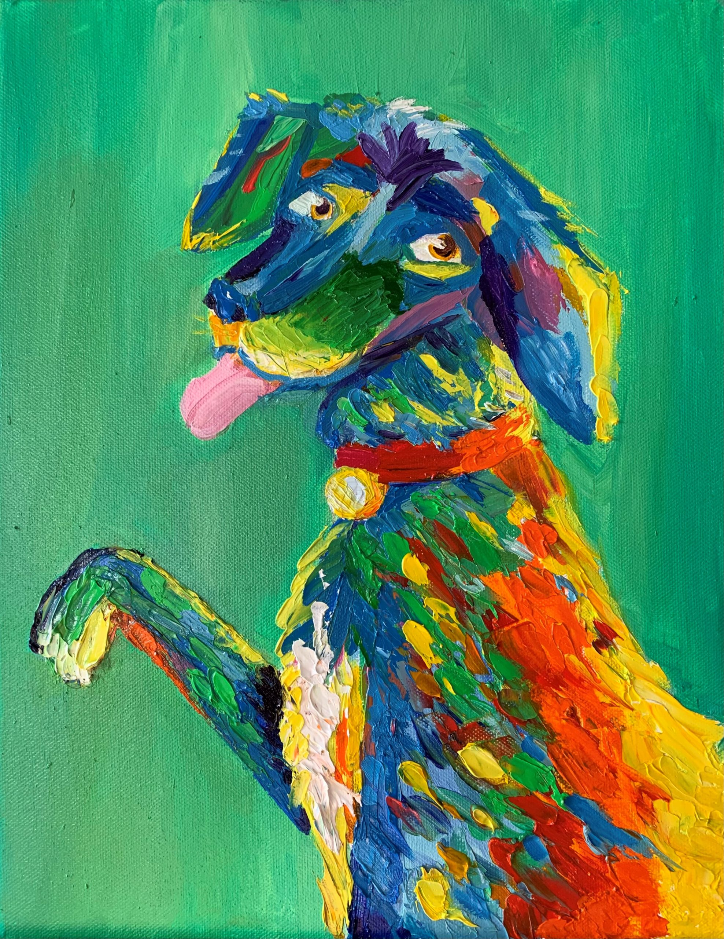

About the Author
Justice Rebmann
is a second-year student at OSU studying French and Creative Writing. Her three great loves are art, writing, and language, and after graduating, she hopes to work in translation and write fiction. She is the recipient of a Gold Key in creative writing from the Scholastic Art and Writing Awards. You can find her artwork on display at the Aspen Coffee on Western in Stillwater, where you might run into her nursing a lavender latte.

How to Identify Terrifying Men
Sydney Sheneman
I have always jokingly referred to myself as being a “magnet for terrifying men.”
“It’s my pheromones,” I say. “They attract every pervert within a hundred mile radius.”
Each time I make this joke, my mind conjures up the same image: me—simply existing—completely unaware of the miles wide, purple-hued cloud of pheromone fog surrounding me. The scene then begins to pan out, revealing herds of greasy old men wearing should-be-white wife beaters, their noses stuck up in the air as they trudge through my thick pheromone smog. Sometimes, I imagine the fog’s aroma to be similar to that of a grape-flavored candy’s—other times, I imagine it carries a more lavender-like scent. Either way, these greasy old men seem to find the smell so enticing that it all but pulls them towards me.
This vision is strange for several reasons:
- They’re usually not old and greasy—the terrifying men, I mean.
- Pheromones are invisible to the naked eye, and, therefore, are definitely not clouds of purple-hued vapor.
- Even if they were, humans aren’t really into the whole pheromones thing.
It’s easy to list off all the ways in which my brain’s purple pheromone fog scenario is unrealistic; what’s not so easy is compiling a list of all the identifying features shared by said terrifying men. In my twenty-years of experience I have discovered that, sure, some of these terrifying men are old, but some of them are thirteen-year-old boys who think that random girls on the internet
really want to be sent unsolicited pictures of their penises. And, sure, some of these terrifying men are a bit greasier than your average Joe, but some of them look as though they just stepped foot off set after filming a commercial for some flashy, overpriced cologne.
There is one thing, though, that I can add to this list—one trait that I know with complete certainty all these terrifying men share.
They most definitely, 100%, do not see women as living, breathing, human beings.
So then, how do these terrifying men view women? I spent some time—too much time, if I’m being honest—scouring the internet for an answer to this question. To nobody’s surprise, I’m sure, I was met with countless tweets about how women are only good for this and that—the this and that typically being sex and housework. I watched endless videos of men sitting in front of microphones insisting that “women are men’s property,” and I forced myself to scroll through the infinite heaps of blatant misogyny expressed by those who find way too much confidence hiding behind the internet’s shield of anonymity.
Out of curiosity—and an intense desire to rid my mind of the colorful opinions the internet had just shown me—I turned to Urban Dictionary: a notoriously unreliable source of information. Oddly enough, though, it proved to be extremely reliable in terms of the information I was looking for. In the little search bar located at the top of my screen, I typed in one word: woman. The first definition to pop up was short and simple yet, somehow, perfectly answered my question of: “how do terrifying men view women?”
Woman
Something me and you have never touched.
👍 👎
2074 165
Again, I am well aware of the unreliability and joking nature of the definitions provided by Urban Dictionary—this knowledge, however, doesn’t change the fact that this particular joke is eerily similar to the ones I’ve heard all throughout my life.
When I was sixteen-years-old, I began working at a fast food restaurant which almost exclusively employed teenage boys. After my first training shift, a friend of mine—the same friend who had suggested I work there in the first place—jokingly informed me that my new coworkers had been “calling dibs” on who would get to “fuck” the new girl. He laughed at this joke, and so did I.
When my adult manager, Noah, began crotch-hugging me each time he needed to grab something located in my general vicinity—there seemed to always be something he needed from a shelf directly above me—these same coworkers would jokingly mimic Noah’s overly-touchy behavior. They would grab one-another by the waist, executing the perfect crotch-hug by thrusting their hips forwards and against the other person’s backside, all while loudly exclaiming some variation of: “sorry, I just need to grab something real quick.” They would laugh at these jokes, and so would I.
The biggest joke I heard during my time employed at said fast food restaurant, though, was the pictures my coworkers traded with one another. While I never saw these photos, I knew what they were: high-school-girls posing naked for the camera, and although it was never said explicitly, I was certain that these nude photos weren’t sent to them specifically, yet somehow
always found their ways into their camera rolls. “Brooooo, look at this.”
“Brooooo, is that Rachel?”
“Yeah, brooooo.”
“Brooooo, send that to me.”
“For sure, brooooo.”
These were all jokes, of course, they all just so happened to have the same punchline of women: something me and you have never touched. The lack of originality in these jokes didn’t seem to be an issue, though, considering how each and every one of them was followed by a loud chorus of laughter.
Now that I’m sitting here thinking about it—truly thinking back on each and every time a man has made me into the punchline of one of these jokes—they almost always laugh afterwards.
They almost always laugh immediately after making a woman the punchline of one of their
jokes.
Each and every time a car full of men has loudly reminded me of my female anatomy—and, more specifically, what they would like to do to my said female anatomy—they laughed. When the man who looked strikingly similar to Fabio—long, flowy hair, and a perfectly chiseled jawline—felt it necessary to tell me how badly he wanted to “get with a blonde” as I scanned his groceries, a snicker followed each of his remarks. Those men who believe that they were put on this earth with the sole purpose of reminding each and every woman they encounter to “smile more” always follow up their lighthearted suggestion with a short chuckle.
Even without the laughter that follows their hilarious jokes, all it takes is one look into a terrifying man’s eyes to know that they are just that: a terrifying man.
They look at you as though you are something they have never touched but really, really want to.
Unfortunately, this means that you have to be close enough to said terrifying man to actually see this look in his eyes—close enough to mean that it’s too late to start speed walking in the other direction, and close enough to mean that you should probably start carrying pepper spray with you everywhere you go.
Being the “magnet for terrifying men” that I am, I have been fortunate enough to have observed this look enough times to be able to identify it in a matter of seconds—I am also fortunate enough to be able to speed walk at what I believe to be a record-breaking pace. There was a time, though, at which I was not yet too familiar with this look—not until I saw it in the eyes of a man who was sprinting full-speed towards me through a near-empty gas station parking lot one night.
I had been driving my then-boyfriend back home when my car suddenly informed me that my tank was getting close to empty. Given that I had only enough gas to last me for about 30 miles—the drive to his house then back to mine was a little over 40—I decided to make a quick stop at the first gas station I saw. Throughout my entire life I had been warned of the dangers of getting gas alone at night, but I figured that the boy sitting in my passenger seat would surely deter any potential opportunists from teaching me why this particular warning exists in the first place.
I learned three things that night:
- My (ex) boyfriend was totally cool with hiding from men who were full-blown charging at his (ex) girlfriend.
- If you plan on using the boy sitting in your passenger seat as a terrifying-men-repellent, make sure he’s actually visible to said terrifying men.
- When a man sprints at you through a gas station parking lot at night, he looks at you as though you’re something he’s never touched but really, really wants to.
It’s the same look I’ve seen in my mother’s eyes as she browses through online catalogs advertising overpriced designer couches. It’s the same look I’ve seen in my cat-loving roommate’s eyes as she shows me kittens listed for adoption on Pet Finder. It’s the same look I saw in Fabio’s eyes as he admired my blonde hair, and it’s the same look I saw in the eyes of the man who asked if I was on the menu as I was taking his order.
That Look
The way middle-aged women look at designer couches they shouldn’t buy but really, really want to; the way terrifying men look at women they have never touched but really, really want to.
👍 👎
0 0
What troubles me most about my list of characteristics shared by terrifying men is that it provides no insight on how to identify a terrifying man before it’s too late. You can’t simply look at a man from across the room and know that he doesn’t see women as living, breathing, human beings, you don’t hear that laugh until after you have already become the punchline of one of their jokes, and if you can see the look in their eyes, you’re already too close. There is no way of knowing a terrifying man is, in fact, a terrifying man until after you have been thrown into an uncomfortable, or, oftentimes dangerous situation with one.
For this reason, I am inclined to describe interacting with men as being similar to playing a game of Russian roulette.
Russian Roulette
A game where a revolver with one bullet is placed and spun. Then you take turns putting the gun to your head and pull the trigger. If it’s empty, you pass it on until someone dies or becomes extremely injured.
👍 👎
438 322
While the “not-all-men” response to women’s fears of men—fears that are commonly developed as a result of repeated experiences with terrifying men—is technically true, it doesn’t change the fact that we are aware of that one bullet in the revolver. The “not-all-men” response is more than just a factual statement—we know that it is not all men. We know that not every man we encounter sees us as less than human—looks at us as though we are something they’ve never touched but really, really want to—but that doesn’t change the fact that it is some men. There is a bullet somewhere in that revolver, and we have no idea which pull of the trigger will send it flying “until someone dies or becomes extremely injured.”
To respond to a woman’s fears of men by saying, “but not all men,” is like arguing that Russian roulette is a perfectly safe game to play. It’s not.
I know that there’s a bullet in the revolver, just as I know that there’s a man walking around who looks strikingly similar to Fabio who really wants to “get with a blonde.” I know that there’s a bullet in the revolver, just as I know that there’s a man who drives past gas stations at night, hoping to stumble upon a seventeen-year-old girl who appears to be alone and vulnerable. I also know that the only way to avoid becoming the unlucky player in a game of Russian roulette is to stay far, far away from the revolver.
How to avoid terrifying men.
- Never go anywhere alone.
- Always carry pepper spray.
- When men yell profanities at you from their cars, ignore them (but in a nice way—you don’t want to make them angry).
- When men approach you when you’re out in public, ignore them (but in a nice way—you don’t want to make them angry).
At some point in my life, I discovered that there is a limit to the number of times you can see that look in a man’s eyes or hear that laugh, wondering if this would be the time you’d have to actually use that pink pepper spray you carry with you everywhere you go. With each of my encounters, I made my way through this list on “how to avoid terrifying men,” and when I realized that none of these methods successfully allowed me to avoid the terrifying men who definitely, 100%, did not see me as a living, breathing, human being, I came up with a fifth approach.
5. Don’t leave your house unless it is absolutely necessary.
For an entire year, I kept myself holed up in my dorm, my heart set on avoiding each and every man in the state of Arizona. I would venture out into the real world only when it was absolutely necessary—which was typically when I had gone through every last bit of food I had stored in my room, and needed to make a quick run to the grocery store. I kept these trips short, but terrifying men had no problem with finding ways to fit themselves into my timely schedule; it seemed as though they were just waiting for the opportunity to remind me of their existence.
In the short, three minute walk from my dorm to the parking garage, one terrifying man found the time to shout profanities at me through his rolled-down car window. In the ten minute walk from my dorm to the CVS around the corner, three terrifying men found the time to follow me from a distance—close enough so that they could inform me of how good my ass looked in my jeans, but far enough away so that they had to do so by yelling. When I realized this fifth method was equally as unhelpful as the others, I added a sixth.
6. If leaving your house becomes absolutely necessary, try your hardest to look as unappealing as possible.
I began throwing on the baggiest clothing I could find each time I left my dorm, and when the interactions with terrifying men persisted, I took more extreme measures. After seeing a video of a man talking about how brunettes are “wifey material,” and how blondes “are just for fun,” I dyed my hair brown to take their fun away. When I saw a video of a man talking about how repulsive tattoos are on women, I scheduled an appointment hoping to make them disgusted.
“Men prefer long hair,” I cut mine to my chin. “Tattoos are ugly,” I got four more.
“Women, please stop getting facial piercings,” I scheduled an appointment for later that day.
In doing each of these things, I believed that I was piecing together a bulletproof vest that might protect me from that one bullet in the revolver.
Woman
Something me and you have never touched.
👍 👎
2074 165
As it turns out, when enough men see you as less than human—as something they have never touched but really, really want to—you begin to adopt their point-of-view. I believed I was crafting a bulletproof vest, but what I was really doing was trying to become something that terrifying men have never touched, but wouldn’t really want to.
They still did, though.
They don’t actually care what you look like, they only care that you’re a woman: something they have never touched but really, really want to.
While a terrifying man might not care about what you look like, how old you are, or—quite frankly—anything else about you, there is one thing he does care about: whether or not you belong to another man.
Example: if a terrifying man were to approach you at, say, a grocery store, there are several things you could say in an attempt to ward him off.
Option #1: “I’m gay.”
Option #2: “I’m 12.”
Option #3: “I have a boyfriend.”
Option #1 would do little to deter him. Remember, he sees you as something he has never touched but really, really wants to, and informing him of your supposed sexuality will not change this fact.
Option #2 wouldn’t work for similar reasons: you are still something he has never touched, but now you’re simply a younger version of this something.
While option #3 will do nothing to change his belief in that you are something, it informs him that you are something that belongs to another man. As stated by those wanna-be-podcasters I mentioned earlier, “women are men’s property,” and to disrespect a man’s property is to disrespect a man.
They only respect a woman’s autonomy when (they believe) she belongs to another man.
Several years ago, my parents began building their dream house, and so for the past few years, they have been meticulously designing and overseeing the construction of their new home. Being that my father typically works most weekdays, my mother took it upon herself to deal with the day-to-day of this extensive project.
Something that women are often warned not to do is develop a routine: if you do the same things at the same places at the same times, someone is bound to notice. Unfortunately, this is exactly the type of routine my mother had formed when she drove her brown Lexus to her new house every day as it was being built. On the days my father was away at work, it was her distinctive car that would be parked on the street in front of the house, but on the days both of my parents would visit their construction-zone of a home, my father would arrive separately and in his white Four Runner.
Brown Lexus = Woman by herself.
White Four Runner + Brown Lexus = Woman with her husband.
My parents decided to switch up this routine one random Sunday when they drove to their new home together in my mother’s brown Lexus which, as always, she parked in the same spot on the street in front of their house. Together, my parents entered their nearly finished home and made their way into their master bedroom; this is where my mother remained as my father went to check out the progress made on their closet, and this is where my mother was standing when a man suddenly appeared at their bedroom’s doorway.
At first, she didn’t recognize him—she assumed he was a contractor she hadn’t yet met until the man began lecturing her about some “trash” that was bothering him. His voice began to raise and his lecturing turned into yelling, which caught my father’s attention.
As soon as my father exited the closet and made his way into the bedroom, the man’s demeanor instantly changed. He took one look at my father then lowered his voice to say, “I’m sorry, I didn’t realize your husband was here.”
Not, “I’m sorry, I was out of line,” or, “I’m sorry for literally breaking into your house,” just, “I’m sorry, I didn’t realize your husband was here.”
When my mother told me this story on the phone, my first thought was: what if he wasn’t there? The man—who turned out to be a new neighbor of theirs—had waited until he saw my mother’s car parked in that same spot on the street in front of her house. He waited until my father’s white Four Runner was nowhere to be seen and for the multitude of (male) construction workers and (male) contractors to be absent from the property.
But my mother wasn’t alone; my father was there and she belonged to him. To disrespect a man’s property is to disrespect a man.
There’s this small tug I can feel in my gut urging me to inform whoever is reading this that I know it’s “not all men.” Despite the fact that each and every one of these stories are things that I have experienced—things that have happened to me and have, in many ways, left me scarred—a small part of me still feels a need to apologize for my brashness. Then I remember that I have never received such an apology; not from the terrifying men who have treated me as something—as less than human—and not from the men who have learned of my experiences and could only conjure up the response of “not all men.”
“Not all men” isn’t just a factual statement. We know that it’s “not all men.” We understand that it’s “not all men.” The only meaning behind those three words is, how can I make this about me. The only thing those three, aggravating words accomplish is making the women who muster up the courage to speak out feel guilty about doing just that.
You shouldn’t feel guilty.
This guilt is dangerous—just as dangerous, perhaps, as those terrifying men. This guilt encourages women to lower their guards, to believe that they are safe from the one bullet in the revolver—that, maybe, that one bullet isn’t even actually there.
If it wasn’t for this guilt, maybe I would have fewer stories to share. Maybe I wouldn’t have brushed off the man who watched me for two hours before cornering me in my register. Maybe I would have told someone about my manager’s frequent crotch-hugs. Maybe I wouldn’t have felt the need to laugh along with so many of those jokes, and maybe I wouldn’t have believed the boy who told me “you can trust me,” moments before he dismissed my “no(s)”.
I am not a “magnet for terrifying men,” and I am not “something a man has never touched but really, really wants to.” To say that I am either of these things is to imply that I am, in some way, responsible for the ways in which I have been treated. I’m not.
I am simply a woman—a living, breathing, human being—who is tired of feeling guilty.

About the Author
Sydney Sheneman
Sydney Sheneman is a junior at Oklahoma State University majoring in Creative Writing. After graduating she hopes to pursue a career in secondary English education and to continue publishing works which bring attention to women’s issues. Currently, she lives in Stillwater, Oklahoma, but hopes to one day return to her home-city Austin, Texas.

The Nativity
KD Leigh
Like an animatronic donkey with a bum knee,
The hayride lumbers past foam props and fake beards,
The figurines posed, paralyzed mid-miracle,
As if da Vinci did the blocking,
Everyone on the same side of the table.
Mother Mary, reclined in her porcelain skin,
Bone-dry brow, relaxed lips smiling sweetly.
The newborn, clean and clothed, already weeks old,
Sleeps so, so soundly.
Now, I will cast the play,
You will be Joseph and I the Virgin Mary,
Though, you’re a little pale, and I a little old,
And not so much a virgin anymore.
Still, you will play Joseph, a picture of faithfulness,
And I will play Mary, a picture of purity.
And we will walk from stage right to stage left,
A donkey, three-wise-men, and an angel between us.
Then I’ll kneel, screaming at the manger’s edge,
Crucified insides, bursting from between my legs.
There, I will give birth, giving and giving,
Bloody mud and hay coating my calloused feet,
And you’ll hold, in your own trembling hands,
The Son, the Savior, Lord of all Dominions,
A son, but not your own.
And you’ll drown baby Jesus in a trough of water,
Because he looks so beautiful, so faultless,
But nothing like you.

About the Author
KD Leigh
KD Leigh (she/her) is a sophomore at Oklahoma State University. She is pursuing dual degrees in English and History and, as a result, spends much of her free time writing essays. Currently, she works as a tutoring consultant for the OSU writing center where she edits other students’ essays. In the future, she hopes to attend graduate school, write even more essays, and continue pursuing her goal of publishing original poetry. In her work, she explores topics such as religious trauma, sexuality, leftist ideals, and mental illness. She currently lives in Stillwater, Oklahoma in an apartment overrun with roommates and possibly too many cats.

1

Appendix
This is where you can add appendices or other back matter.

