How to Record Vocals in Ableton Live 9
Ableton Live 9 is a world-class, studio Digital Audio Workstation (DAW) aimed toward live-performances and DJs, but can also be used to record, mix, and master any audio project including solo artists or bands. Recording properly is an important aspect of achieving a quality outcome for your musical projects and will help your audio sound professional. This manual will guide you through the process of setting up and recording vocals into Ableton Live 9.
Tools Needed:
- Ableton Live 9 software  - Computer (See System Requirements)  - Microphone  - Microphone stand  - Pop filter  - Audio interface  - Headphones  - XLR cable(s)  - Various other cables | Image Source: NejroN / 123rf.com

Ableton Live 9 System Requirements:
(Information retrieved directly from Ableton User Manual*.)

Windows:  - PC with Windows 7 (with SP 1), Windows 8, or Windows 10  - Multicore processor  - 4 GB RAM  - 1024x768 display  - DVD drive or broadband internet connection for installation | Mac:  - Intel® Mac with Mac OS X 10.7 - MacOS 10.13  - Multicore processor  - 4 GB RAM  - 1024x768 display  - DVD drive or broadband internet connection for installation

Connecting to the Computer
Your audio interface is the bridge that connects the microphone to the computer. Without this, Ableton will not acknowledge your audio input. This section will guide you through connecting an audio interface to a computer and microphone. Let’s get started!
- Connect audio interface to computer
Power on the interface if necessary. Refer to the audio interface manual for more information.

- Open Ableton Live 9
- In Windows, click Options; in OS X select the Live menu
See figures 1.1 and 1.2 below.
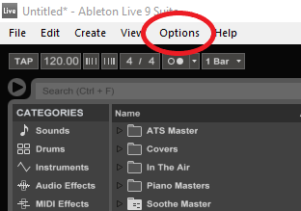
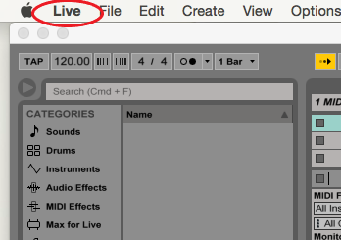
Figure 1.1: Windows Options Figure 1.2: Mac OS Live Menu
- Choose Preferences tab

- Click on Audio
See figure 2

Note: Ableton Live 9 has an audio setup wizard that will direct users through setting up audio interfaces and other devices compatible with Ableton. If you have any problems during this step, the audio setup wizard can be very useful.
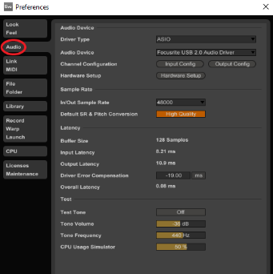
Figure 2
- Select driver type ASIO from the drop down menu  See figure 3 |  | 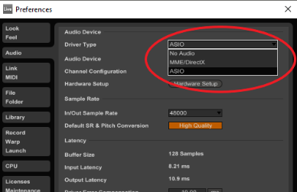  Figure 3: ASIO is listed in the drop down menu just above the Audio Device menu
- Use Audio Device drop down menu to select your audio interface
If you do not see your device, please refer to the Troubleshooting Guide.
- Enable Test Tone and adjust volume so that you can hear the tone  See figure 4 | 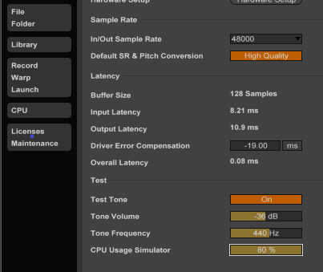
- Increase CPU Usage Simulator to 80%

- Adjust Driver Error Compensation so that Overall Latency is as close to 0ms as possible without causing glitches or audio artifacts

- Disable Test Tone

- Exit Preferences | Figure 4: Test tone is On and CPU Usage Simulator is set at 80%

You Are Connected!
Your audio interface is now optimized and connected to Ableton Live 9. Driver Error Compensation is now set as low as possible on your PC or Mac, which allows for the smoothest audio playback experience possible with your hardware. Now, let’s set up the microphone.

Setting Up the Microphone
Proper setup of the microphone is crucial to capturing good quality audio. Generally, a condenser microphone is used to capture vocal takes, though a dynamic microphone is also suitable. Pop filters will assist in removing unwanted plosives. The following will assist you in a general setup for recording vocals.
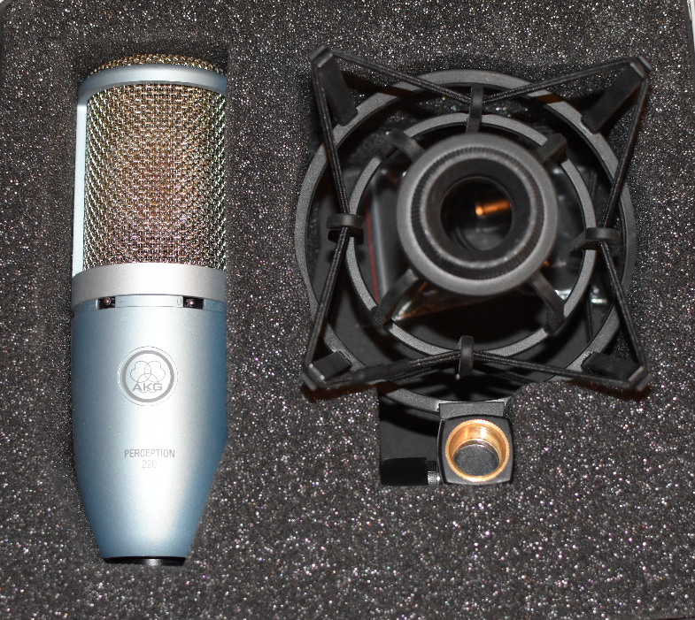
Standard Condenser Microphone – Notice the
diaphragm visible underneath the wire mesh

Note: While dynamic microphones need only be plugged in for use, a 48-volt phantom power supply is needed for a condenser microphone to function. Your audio interface may include one. Please refer to your audio interface manual for this information.
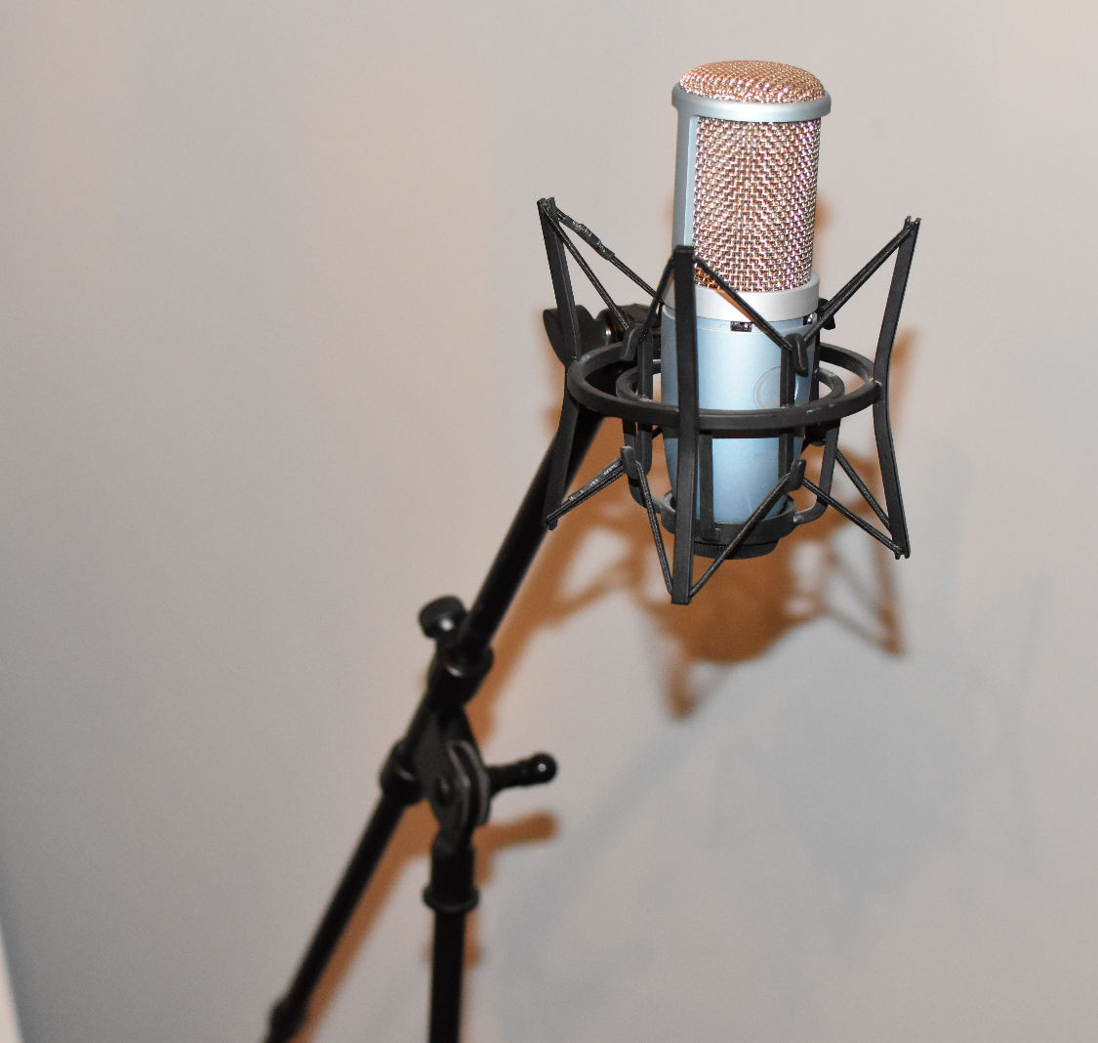  - Place microphone on microphone stand so that it resembles figure 5  Figure 5: Condenser mic with shock mount  on a boom-style stand | - Attach pop filter to microphone stand near microphone  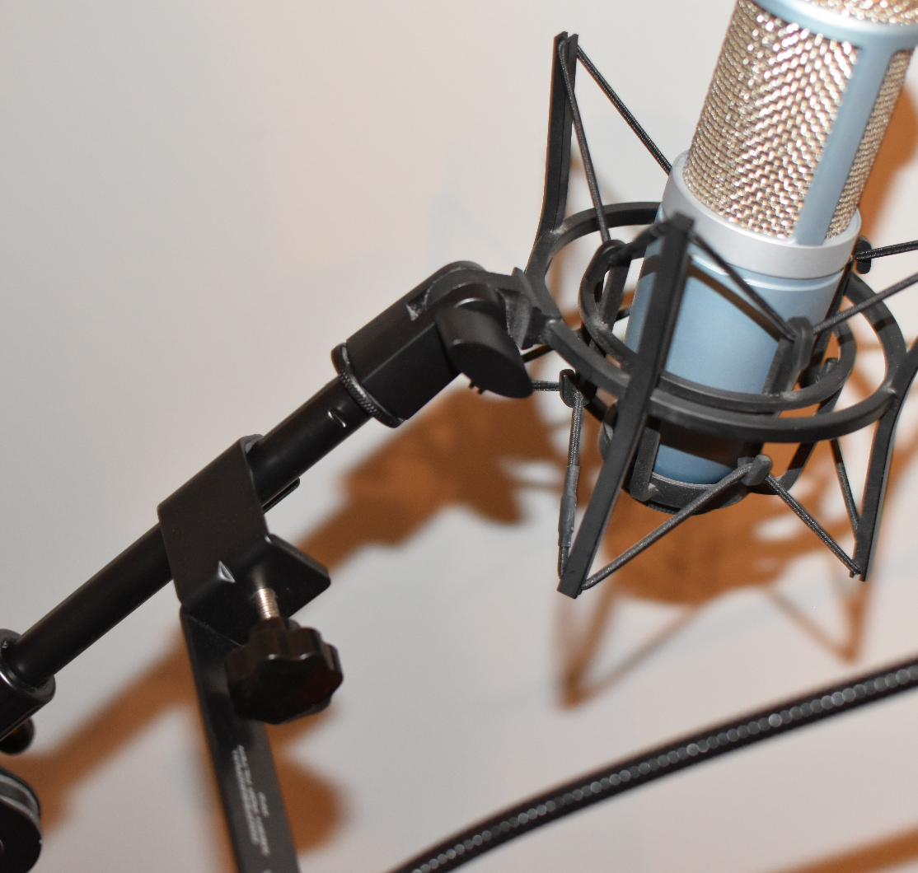  Figure 6: Pop filter (seen with screw attachment) is connected close to mic for mobility
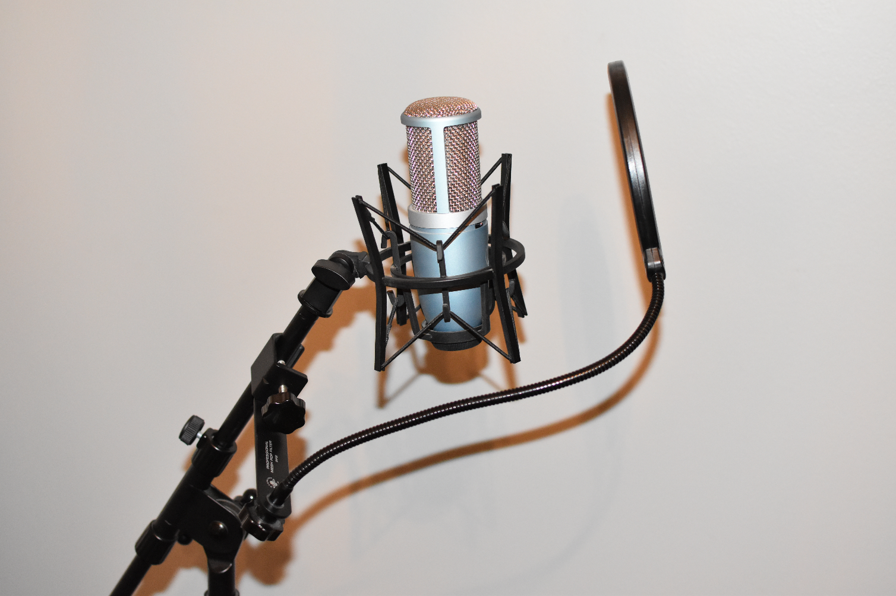  - Position pop filter approximately 4-6 inches from the microphone as shown in figure 7 |  | Figure 7 (Left): The pop filter should be placed between vocalist’s mouth and microphone with the mesh facing the talent. For more information about using a pop filter, consult the Helpful Tips section at the end of this manual.
- Adjust height of stand and position of microphone to a comfortable level for talent | 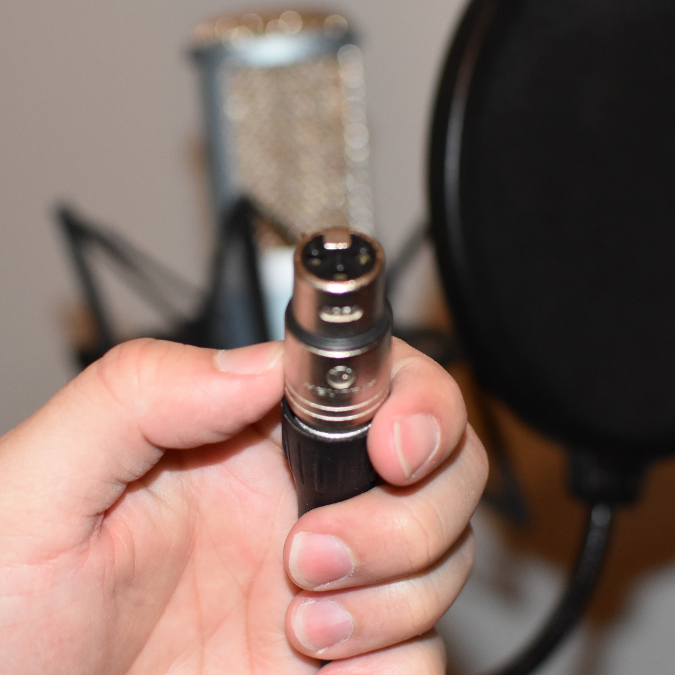
- Connect microphone to audio interface using XLR or 1/4” cable

Figure 8 (Right): One end of an XLR cable. These and 1/4” TRS jacks are the most common cables used for microphones. XLRs are handy because they are usually balanced, providing a cleaner signal by reducing unwanted noise.

Your Mic is Set!
Your microphone should now be set up and ready to use. You may run into sound issues later while recording. If this happens, refer to the Troubleshooting Guide. For advice about placement, see the Helpful Tips section.

Recording a Vocal Take
After the microphone and audio interface are connected to Ableton, you are ready to record. In this section, you will set Ableton ready to record to an audio track, also known as “arming.”. For the purposes of vocal recording, we will not discuss setting up to record MIDI tracks as microphones need only be recorded to audio tracks.
  - Arming the Track
- Switch Ableton to Arrangement View as shown in figures 9.1 and 9.2
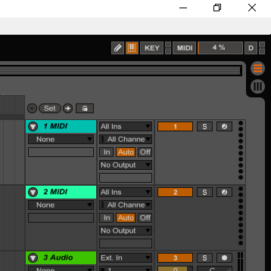
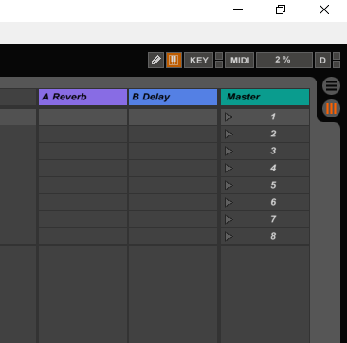
Figure 9.1: Session View is shown activated Figure 9.2: Arrangement View is activated
- Set input on track to match that of the microphone connected to audio interface  Ex: Select ‘Input 1’ in Ableton if the cable from your microphone is connected to Input 1 on the audio interface. Figure 10 shows that the track is set to record from input 1 as noted by the “1” bellowed “Ext. In.” | 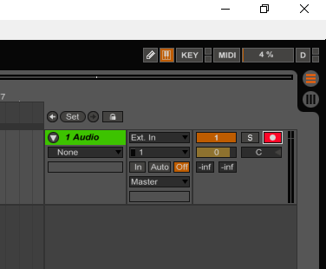  Figure 10: Track “1 Audio” is armed as identified by the record button highlighted in red.
- Set your track to record by clicking the Arm button
See figure 10
- Set Monitor output to “Auto”  See figure 11 | 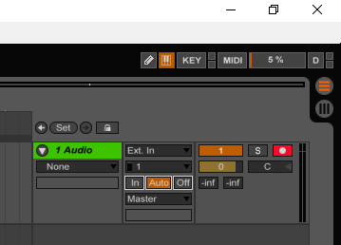  Figure 11
- Using headphones for reference, check audio levels from microphone

Have your talent project into the mic as they intend to during performance and adjust input volume until Ableton shows no less than -20dB for their quietest singing and no more than -3dB for the loudest. This will ensure a good take without being too quiet or subject to clipping at higher sound levels.
  - Recording a Take
- Activate recording by clicking the Arrangement Record button or using keyboard key F9  See figure 12.1 | 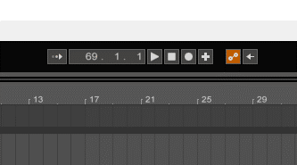  Figure 12.1
- Record take
- Click Arrangement Stop button, or use F9 or Space Bar to stop recording/stop playback | Figure 12.2
- Press Arrangement Play button or Space Bar to listen to playback  To record a different take delete existing take, record over existing take, or set up a new audio track. | Figure 12.3

You Are Done!
There should now be recorded audio within your project. If there is no audio, run through this manual again and try to find any steps you may have missed or refer to the Troubleshooting Guide.

Congratulations!
If you have carefully followed this guide, then you should have successfully recorded vocals in Ableton Live 9. Ableton also allows users to connect multiple microphones and record simultaneously as long as your audio interface has more than one input. Consult the technical manual for your audio interface to determine whether or not yours is capable. If you have issues with recording, please refer to the Troubleshooting section of this manual.

Helpful Tips

Pop Filter
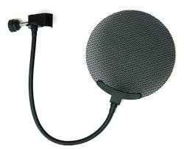
Virtually all professionally recorded vocals utilize pop filters. Though use of a pop filter is not necessary to record vocals, there are multiple advantages to using one. The main use for a pop filter is to control, or eliminate, plosives that occur from “p” or “b” sounds while singing. A pop filter should be placed around 4”-6” away from the mic, preventing talent from moving too close which can cause a proximity effect in cardioid pattern microphones. This can cause too much low-end or a change in frequencies captured making mixing and mastering more difficult. Lastly, pop filters may also help control sibilance during vocal takes due to the material used.

Mic Placement & Posture
Microphones should be set comfortably for the talent. The talent should stand, if possible, and avoid bad posture. Straightening the back and neck, positioning feet shoulder-width apart, and relaxing limbs will result in better performances with more control. The mic should be placed in a such a way that this posture is reinforced. Boom stands are ideal for studio settings due to their adjustability. It is also recommended to have a shock mount for your microphone to avoid picking up undesirable bumps and sounds that travel through the floors.

Acoustic Treatments
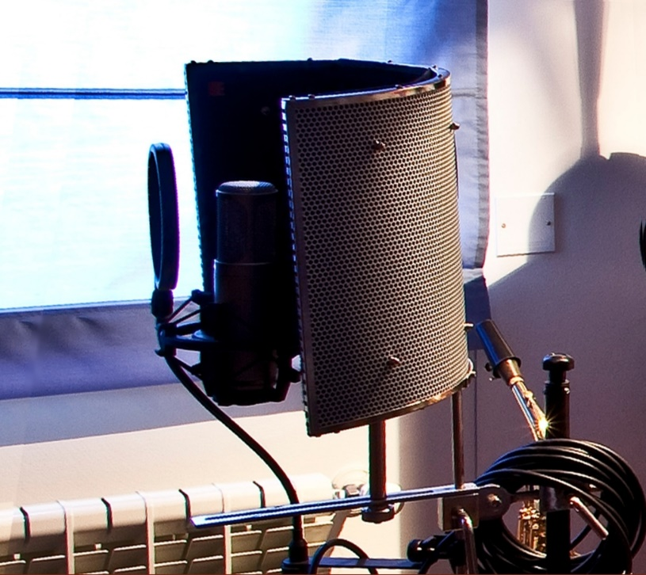
What often sets professional studios apart from home studios, outside of higher quality gear, is the acoustic treatment of the recording booth/room. Unless it is the sound you’re trying to achieve, acoustics can make the best vocal take impossible to manage. Adding sound dampeners (like this reflection filter) will help reduce acoustics within a lively room giving you more options to mix and add your own effects to a vocal track. Standing partitions or foam padding placed on walls will reduce acoustics. For home studios, carpet, rugs, or even furniture placed within the room can lower unwanted acoustics. Get creative!

Troubleshooting Guide
Symptom | Possible Cause(s) | Solution
No sound | No power to condenser microphone. | Check your audio interface for a switch to enable phantom power, or enable your phantom power supply.
 | Faulty cable. | Change cables and inspect for any damage that can compromise integrity.
 | Input volume too low/muted. | Check the volume on your audio interface as well as Ableton to determine if the software is receiving a loud enough signal.
 | Input for microphone not selected or monitor not activated in Ableton. | Ensure that the armed track is routed to the correct input for the microphone and that the monitor in Ableton is set to “Auto” or “In.”
Ableton cannot find audio interface | No power. | Ensure that the audio interface is receiving power.
 | Drivers not installed. | Refer to your audio interface’s user manual for information about installation and to determine compatibility.
Glitches or noise artifacts in playback audio. | Ableton Live or audio interface not up to date. | Check Ableton and your audio interface for software/driver updates.
 | Driver Error Compensation set too low/incorrectly. | See steps 8-11 of “Connecting to your Computer” section of this manual for instructions on setting up Driver Error Compensation. If this is set too low, the computer’s processing power will be unable to keep up with the overall latency and will produce undesirable results.

For more information, refer to the respective instruction manuals for your hardware.
* DeSantis, Dennis, et al. “Ableton Live 9 User Manual.” Ableton, Ableton AG, 2016,
cdn-resources.ableton.com/80bA26cPQ1hEJDFjpUKntxfqdmG3ZykO/static/
manual/pdf/L9Manual_EN.pdf.

