Oklahoma State University
Dr. Ashley M. Burkett
GEOL1003: The Story of Dinosaurs
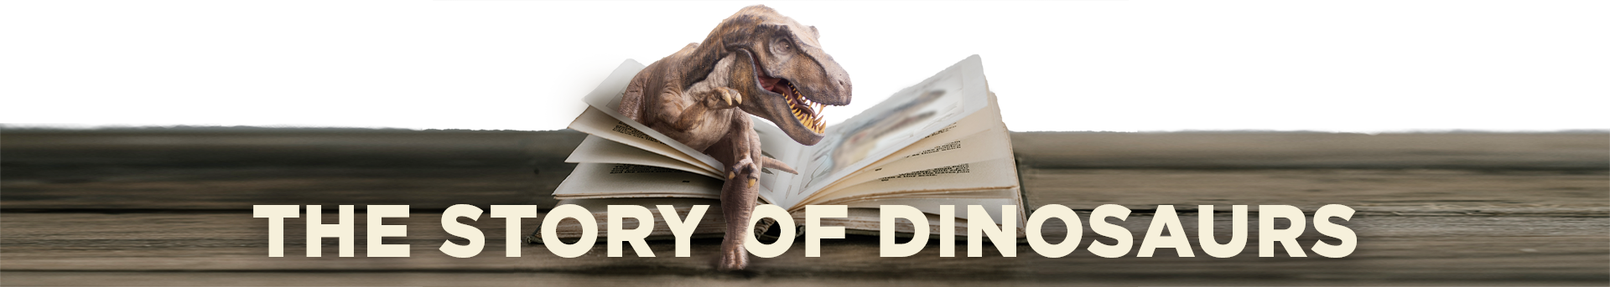
Notes with Gaps: What is a dinosaur?

This week we will be exploring the definition and shared characteristics of dinosaurs. Given that they occupied a variety of ecological niches from 240-65 million years ago, characteristics that make a dinosaur a dinosaur may be much wider than you imagine.

Introduction and Scientific Method
Define the following terms:
- Hypothesis
- Scientific Theory

True or False (circle one): Something that is “proven scientifically” is considered by scientists as being a fact, and therefore no longer subject to change.

What is a dinosaur?
Who was the first to discover and describe dinosaurs?

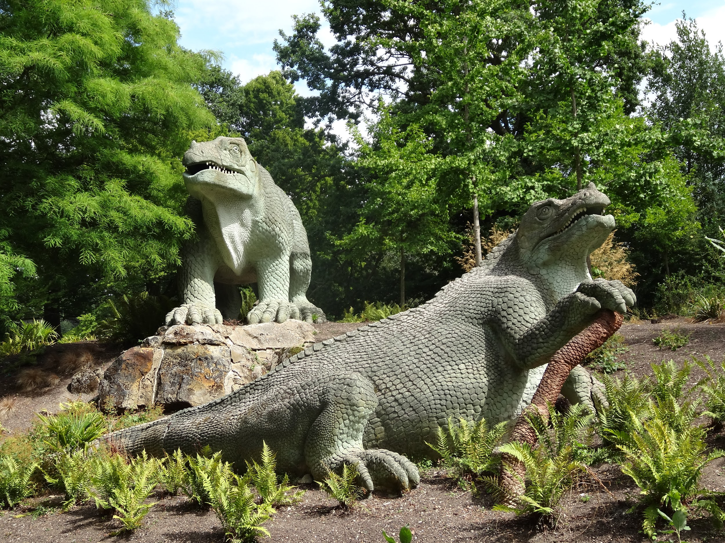
Above is a photo of a sculpture of Iguanadon in Crystal Palace in London, England. These sculptures are considered correct/incorrect (circle one) by today’s standards as reconstructions of what Iguanadon looked like. These sculptures were commissioned in 1852 to highlight the recent discovery of Dinosaurs (“terrible lizards”) by Sir Richard Owen. Sir Owen directed anatomical features of the sculptures to be as scientifically accurate as possible and when they were unveiled in 1854 they became the first dinosaur sculptures in the world.
Feeding Strategies - Fill in a simple definition of each feeding strategy definition below.

- Carnivores-
- Herbivores-
- Bacterivores-
- Omnivores-
Make a list below of characteristics you think could be used to define whether and animal is a dinosaur or not. DON’T SKIP TO THE NEXT PAGE UNTIL YOU ARE DONE!

How to identify a Dinosaur:
- Archosaurs
  - Number of holes in the skull
- Legs under them
  - Determined through ankle bones
- Laid amniotic eggs

How to identify the type of Dinosaur:
- Orientation of the pelvis
  - Bird-hipped or Lizard-hipped
- Teeth and mouth structures
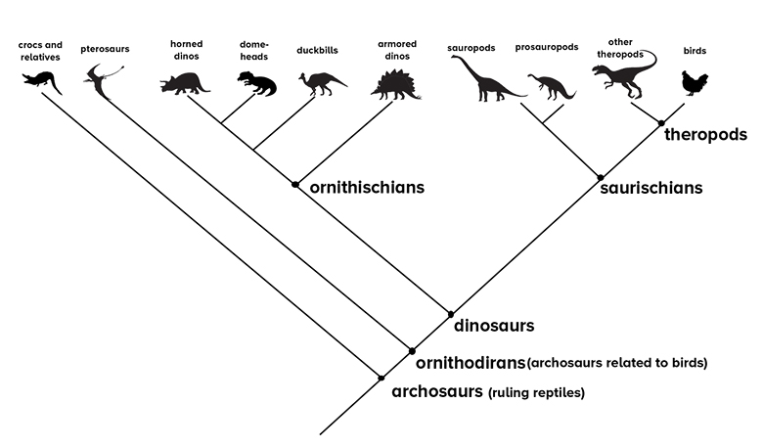
https://www.sciencefriday.com/educational-resources/how-do-you-figure-out-how-dinosaurs-walked/

L1- Exploring dinosaur phylogeny
What are characteristics consistent for all dinosaurs?
- 1
- 2
- 3

What features/characteristics are common to some dinosaurs, but not all?

Lizard hipped or bird hipped? What does that even mean?

Which hip structure did birds evolve from?

When did dinosaurs first appear in the fossil record?

2- Dinosaur Coloring Book

Based on our discussion of dinosaur hip structure, color the pubis, ilium, and ischium different colors in each hip layout. Then proceed to color the hips of the dinosaur fossil illustrations. Use this information to identify if the dinosaur is a member of the Saurischian or Ornithischian group (superorder).

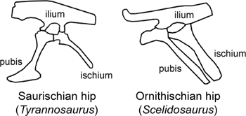
Pubis color= 🖵, ilium color= 🖵, and ischium color= 🖵

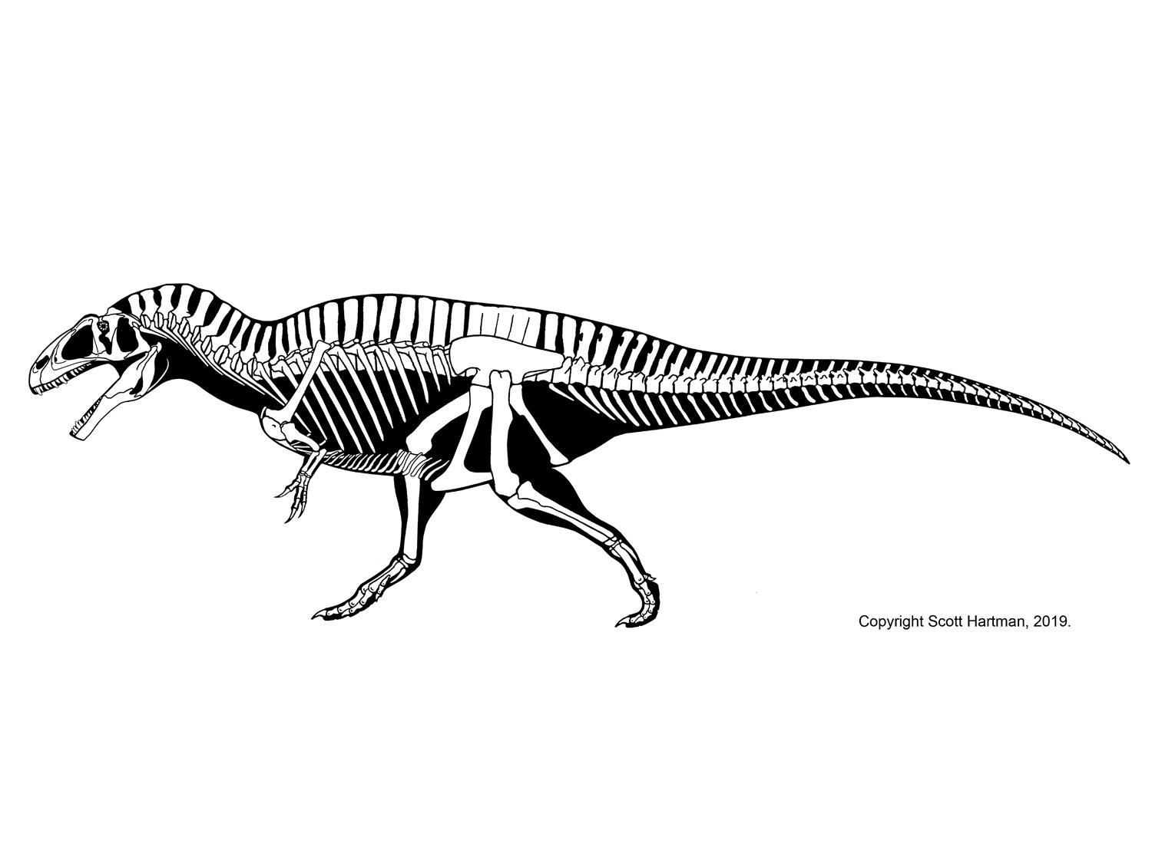
Saurischian or Ornithischian (Circle One)
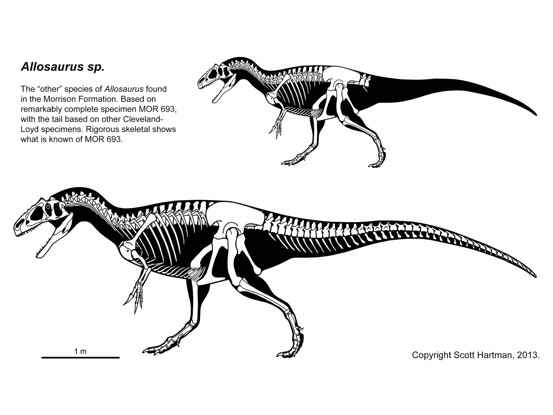
Saurischian or Ornithischian (Circle One)
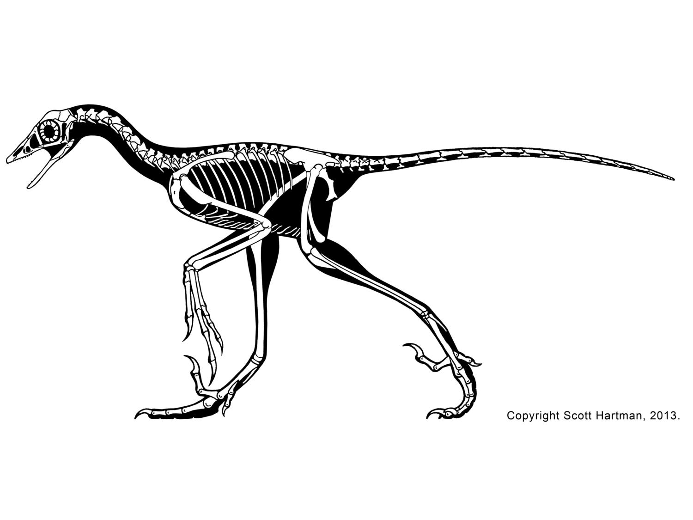
Saurischian or Ornithischian (Circle One)
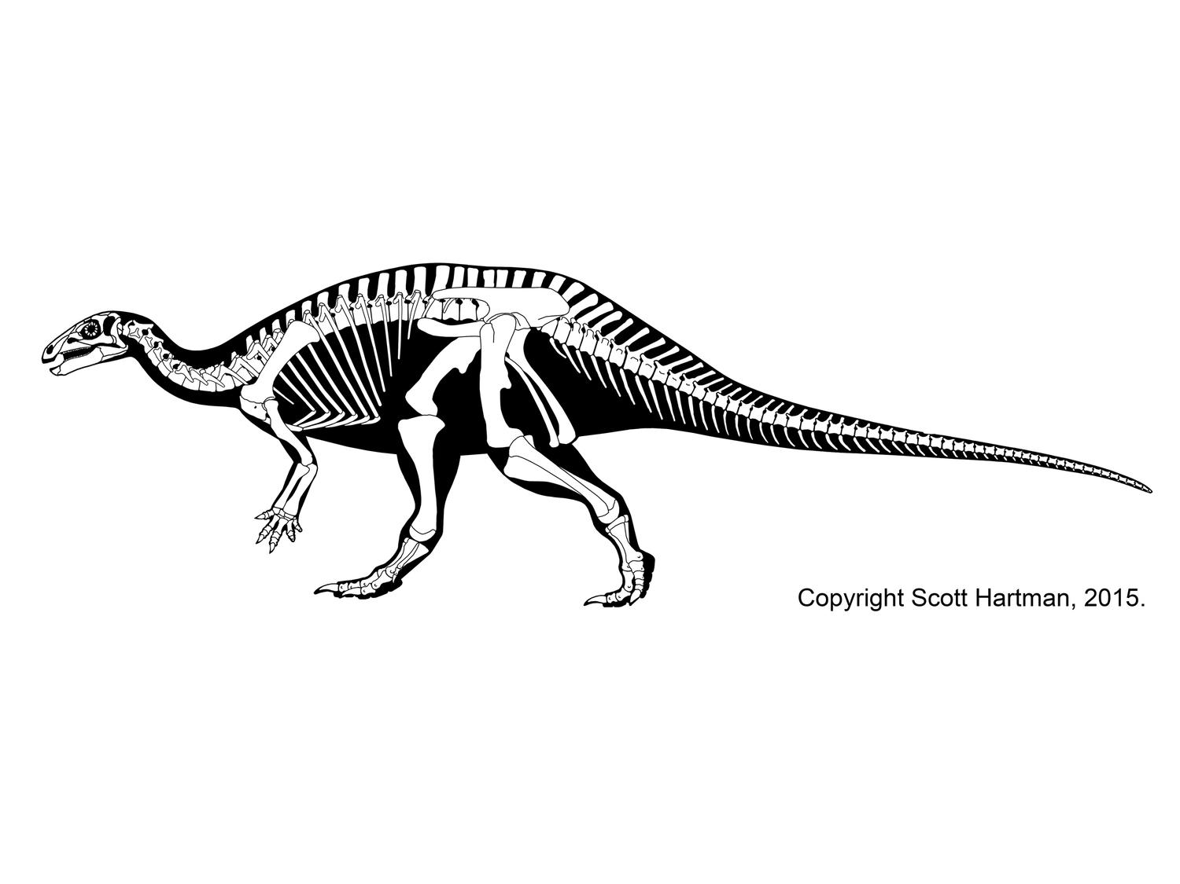
Saurischian or Ornithischian (Circle One)
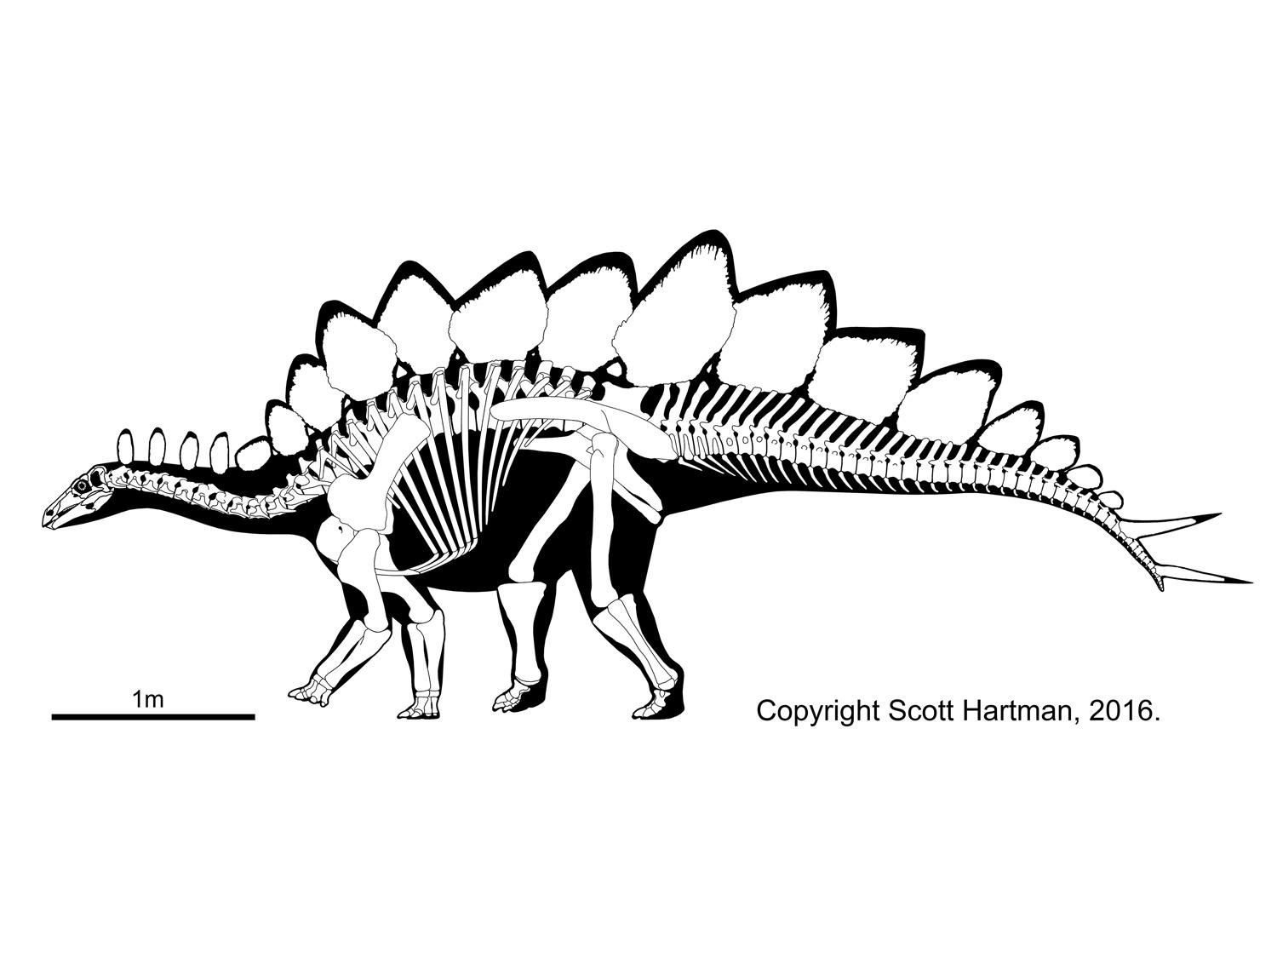
Saurischian or Ornithischian (Circle One)
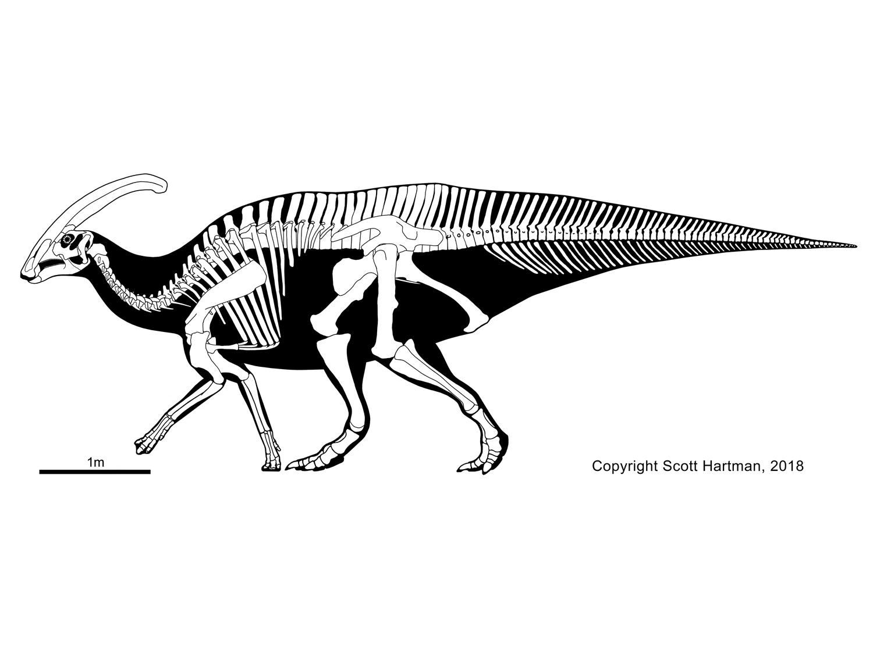
Saurischian or Ornithischian (Circle One)
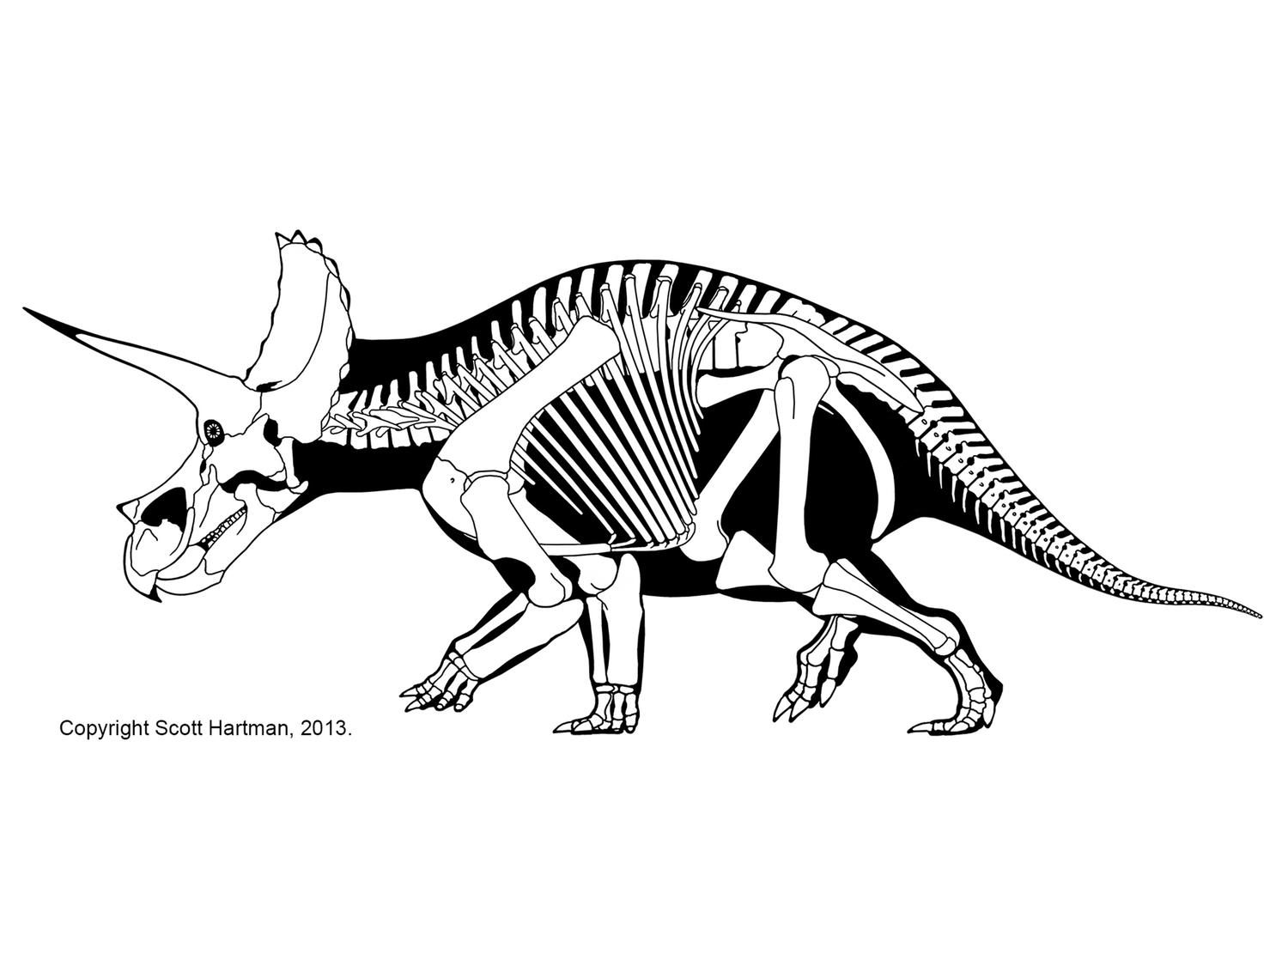
Saurischian or Ornithischian (Circle One)

3- Cladistics
How to we group things with like characteristics?

Define the following in 1 sentence or less:
- Cladogram-

- Evolution-

Using candies as an example group things with like characteristics together. Build them out into a tree and connect them into a cladogram. Remember that each node represents a shared characteristic of the candies. Draw two different cladograms below and label shared characteristics at the nodes.

Scientific Naming of Dinosaurs
- Kingdom Animalia
  - Phylum Chordata
    - Subphylum Vertebrata
      - Class Reptilia
        - Subclass Diapsida
          - Infraclass Archosauromorpha
            - Superorder Saurischia
              - Order Theropoda
              - Order Sauropodomorpha
                - Suborder Prosauropoda
                - Suborder Sauropoda
            - Superorder Ornithischia
              - Order Ankylosauria
              - Order Stegosauria
              - Order Ceratopsia
              - Order Pachycephalosauria
              - Order Ornithopoda

Using this classification, place an arrow where the following organisms stop having shared characteristics with dinosaurs: mammals, humans, snakes, turtles, bacteria, Stegosaurus, Tyrannosaurus, Parasaurolophus

